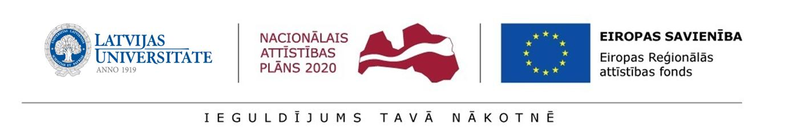Annex 1.5
Regulation of the University of Latvia on the second round preliminary selection of postdoctoral applications

CONFIRMATION
by the structural unit of the University of Latvia
for second round preliminary selection of postdoctoral applications at the
UNIVERSITY OF LATVIA
for submission to the State Education Development Agency (SEDA) for the research application selection round for Activity 1.1.1.2 “Post-doctoral Research Aid” of the Specific Aid Objective 1.1.1 “To increase the research and innovative capacity of scientific institutions of Latvia and the ability to attract external financing, investing in human resources and infrastructure” of the Operational Programme “Growth and Employment”

Hereby I certify that I have been informed and I agree that

________________________________________________________________________________

(name of structural unit)

- If the research application _________________________ (title) is approved, the postdoctoral researcher __________________________________ (given name, surname) shall implement the research application within the scope of the Activity 1.1.1.2 “Post-doctoral Research Aid” of the Specific Aid Objective 1.1.1 “To increase the research and innovative capacity of scientific institutions of Latvia and the ability to attract external financing, investing in human resources and infrastructure” of the Operational Programme “Growth and Employment” at the referred to structural unit.
- A new position for a researcher within the meaning of the equivalent of full working time shall be established.
DEFINITION OF THE YOUNG RESEARCHER – a new position within the scientific personnel is created at the scientific institution and appointing to the position a person who has no previous employment relations with the employer or a person who previously held an academic position at the scientific institution as a lecturer, assistant professor, associate professor or professor.

- The postdoctoral researcher has access to the necessary infrastructure for the implementation of the research application (equipment, workplace facilities, materials).

- Sustainability of the result attained as the result of the implementation of the research application shall be ensured at least for a period of five years after the completion of the research application, including sustainability of the workplace created within the scope of the research application and the development of the research direction in accordance with Paragraph 73 of SAO Cabinet Regulation and and monitoring indicators specified in Paragraph 6.

Faculty/institute __________________/_____________/________________/__________
dean/director signature transcript of signature date

Agreed by:

Faculty/institute __________________/_____________/________________/__________
executive director/director signature transcript of signature date

