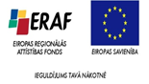

University of Latvia
Research programme 2015 -2020

Approved by the Senate of the University of Latvia
(25/01/2016, decision No. 268)

Summary

Table of contents

Rector’s Foreword: The University of Latvia is Changing for the Future 3
Foreword by the University of Latvia Vice-Rector for Exact, Medical, and Life Sciences 6
Foreword by the University of Latvia Vice-Rector for Humanities and Education 8
Foreword by the University of Latvia Vice-Rector for Social Sciences and Law 10
Summary of the Research Programme 11
The Research Programme in Exact Sciences 15
The Research Programme in Medical and Life Sciences 22
The Research Programme in Social Sciences and Law 29
The Research Programme in Humanities and Education 37

Rector’s Foreword: The University of Latvia is Changing for the Future

Context

In order to be able to maintain and improve the University of Latvia position in the global research space, interdisciplinarity and applicability of research to the solution of different challenges in today's society are increasingly important; we as a national research University have to adapt to external changes, while maintaining our traditions and values which have empowered us since 1919. It is only by adapting to the surrounding environment changes and changes in the demand determined by the global and national levels of society, science, technology and market trends, that we can make the University of Latvia able to educate and attract high-level scientists and scholars who would contribute to the competitiveness of Latvian economy and social development through international scientific discoveries and knowledge transfer.
To become a leading research institution in the Baltic Sea region, the UL requires strategic direction and development acceleration. To ensure this, the UL research development strategy for 2015-2020 has been worked out. The document contains four UL research programmes, the UL institutional development plan and the human resources development plan. These sections have been developed by the joint effort of all the representatives of the interested parties which have made a major contribution to the future vision and strategic approach definition. In the course of development, national-level research policy planning documents (including Latvian Smart Specialisation Strategy), the current situation and its future development potential, the prevailing global science trends have been taken into account. The strategy document sections are complementary in setting common goals and tasks for research fields, based on the following principles: integration of research and studies, achievement of internationally significant research results, transfer of knowledge and commercialization, promotion of science and scholarship in society, organization of research work culture and establishment of priority directions. To achieve the objectives, it is essential that all the parties involved understand the need for change and support it by active involvement in the promotion and implementation of the changes.

Reforms
One of the major organisational changes in research activity is the faculties’ and research institutes’ merging into four field groups, under the supervision of the Vice Rector. Further steps will involve greater support of research personnel to promote project and research work, relieving research personnel of administrative activities. These are just some examples of the many activities justified by the need to focus UL internal resources by promoting cooperation both within and among research fields in order to increase research capacity. Each of the branches has level targets and ambitious indicators of percentage increase in results set for them, taking into account both the current situation and the future UL potential.
In any change process, it is important to address the question of expected benefits. The UL research personnel will gain from the changes in terms of increased administrative support, thus, moving to a system where research personnel are provided high-quality support services ranging from project elaboration to support in the attendance of international conferences. Students, particularly at the doctoral level, can expect greater involvement in research activities, which will promote research excellence and create opportunities for them to become the national research university main promoters. UL staff, students and the general public at large will have a research university of national significance with a clear action plan aimed at overcoming short-term and medium-term challenges and providing a new quality research and study process.
Benefits for research branches are attributable to the development of joint objectives and indicators of progress and regular evaluation of the same.

Excellence

To achieve results in the research excellence strategy, it is essential to focus activities on achieving synergies between research field groups. One of the ways to do this is by field groups’ attracting research staff from other research field groups into their priority research areas.
In the framework of the UL research activities development strategy 2015-2020, each of the four groups defined its areas of excellence, which will be the main driver in the achievement of research programme objectives. Each of these twenty-two fields has the potential for cooperation with at least one other research field group (Figure 1). However, research fields’ definition is just the first step towards our stated vision. The next step is the need to involve in these areas of excellence as much as possible other fields’ personnel, thus achieving synergy within the University, and improving the overall UL research capacity. This is a part of the changes that we need to implement in order to change the UL for the future.

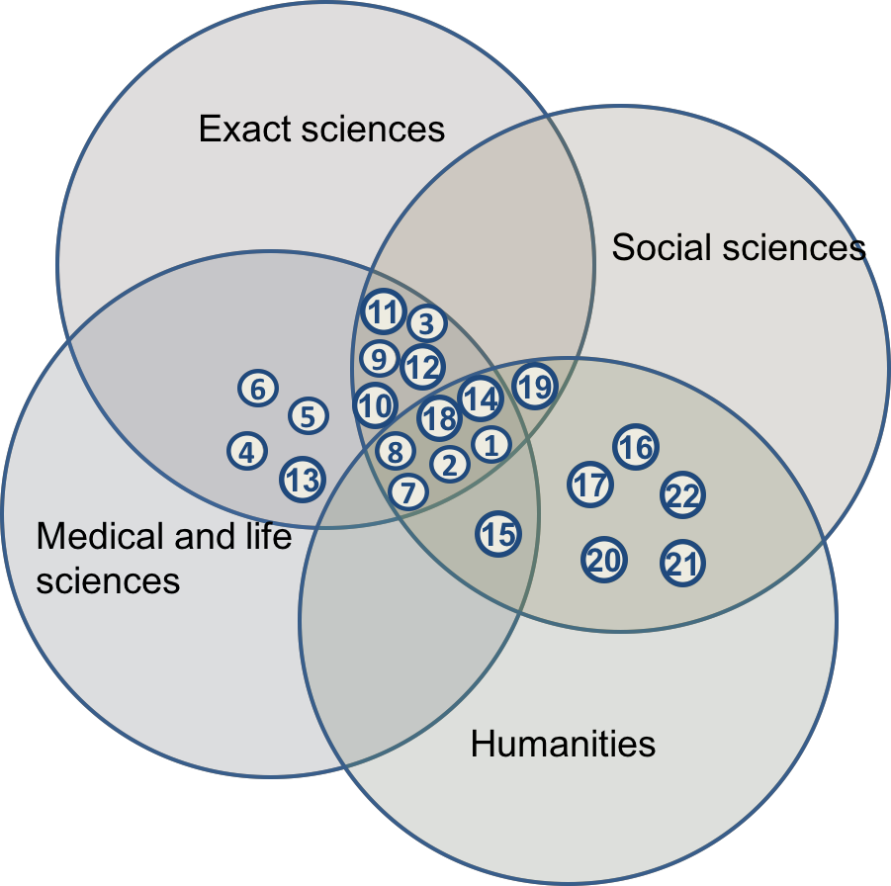

Figure 1 Areas of excellence of research fields and their potential for cooperation with other research fields at the University of Latvia.

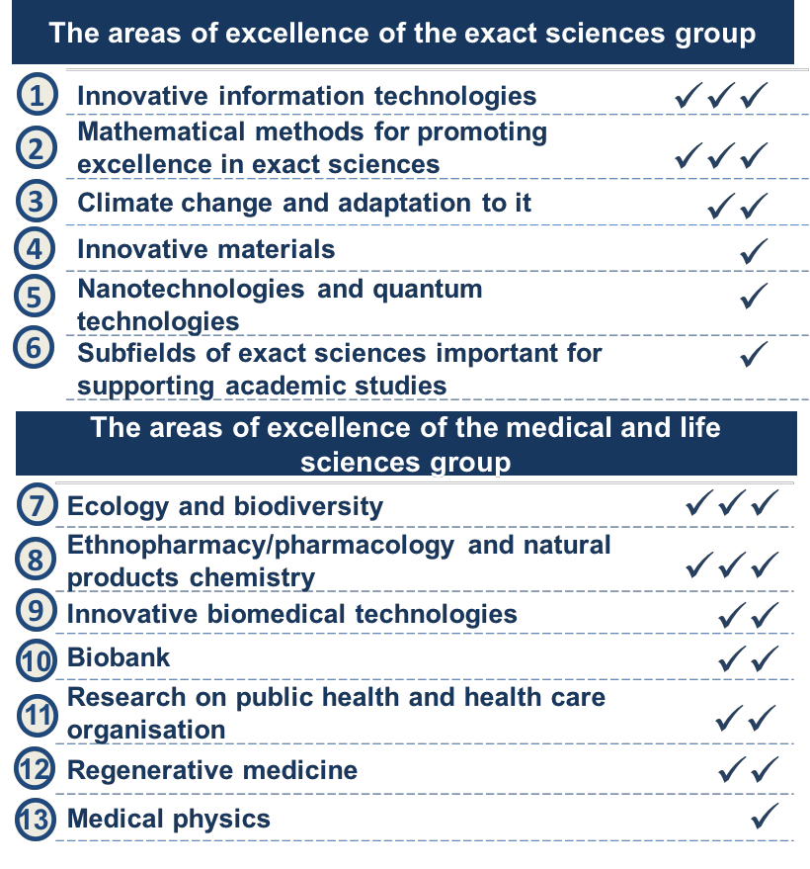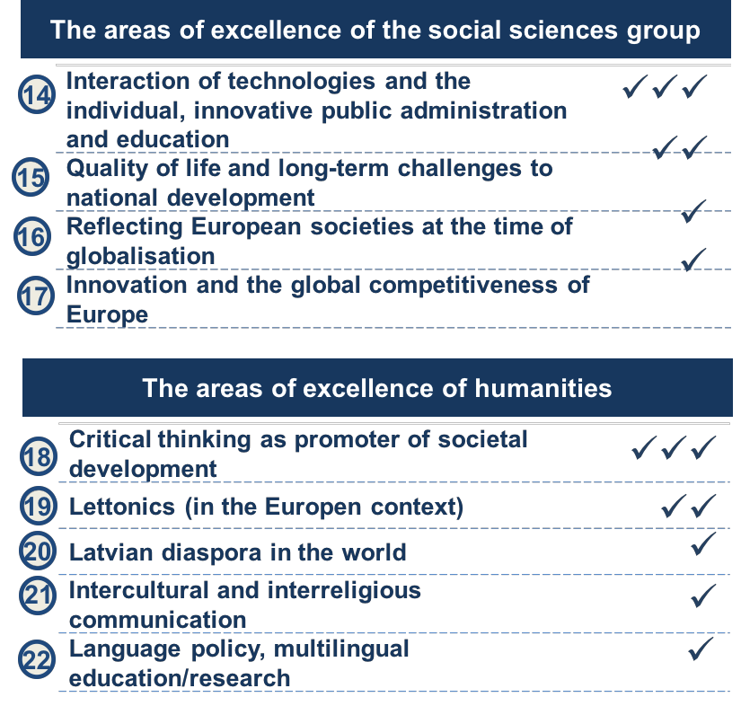
Figure 2. Areas of excellence of research fields groups at the University of Latvia

Foreword by the University of Latvia Vice-Rector for Exact, Medical, and Life Sciences
The further development of research in the field of exact sciences at the University of Latvia requires a common vision regarding the main objectives and the road to be taken to achieve these objectives. Therefore we have jointly developed a detailed version of the research programme in which the current situation in every scientific field has been identified, taking into account the historical experience and possible future outcomes, as well as prepared a report providing a common strategic framework for the entire exact science group as a whole. This document also serves an additional function of promoting the common identity of exact sciences, which is an important prerequisite for successful joint work in achieving the goals of becoming applied research leaders in the Baltic States and full-fledged partners in the European research community.
As far as applied research is concerned, the volume of funding, the establishment of a network of cooperating partners and commercialisation of research and knowledge transfer, all have important roles. Although the private funding of science has been gradually increasing over the recent years, the volume of contract research is still relatively small. Therefore, the sciences of this group will need to pay an increasing attention to the raising of funds and use both foreign sources, especially from the EU programme "Horizon 2020", as well as seek funding from the private sector. This process relies on scientific excellence and the creation of commercially applicable knowledge and technology transfer, which is possible by developing and implementing targeted research commercialization methods, as well as by involving the administrative resources of the University of Latvia for assisting research personnel in attracting and implementation of projects.
In addition to academic research and studies, the creation of knowledge and technology transfer are important driving forces in the development of science, and will continue to be of great importance in the future. Although the research groups have already diversified funding sources (the Latvian Science Council funding, Latvian and European Union public funding, commercial contract research and projects funded by the University of Latvia), private funding is still relatively low. Therefore, more attention should be paid by the medical and life sciences fields in the future to achieving an optimal balance between the time and resources devoted to the academic studies, research, and knowledge transfer. To relieve the scientific personnel of the UL from various administrative procedures (particularly project applications and the preparation of documents required for the implementation of projects) we will increase the administrative capacity of the University of Latvia, improving internal support functions and processes.
Multidisciplinarity and international cooperation are the keywords that characterise the current scientific development in both the European and global contexts. Therefore, for medical and life sciences at the University of Latvia to increase their research capacity and to continue the process of integration in the international scientific community, it is necessary to enlarge the network of scientific cooperation and to increase the number of projects with other research fields at the University of Latvia, as well as with cooperation partners in Latvia and abroad. The main driving force of this process in the future will be research activities in priority areas, where significant effort has already been invested, and which coincide, on one hand, with the Latvian economic growth priority research directions defined in both the Latvian Smart Specialisation strategy and in European guidelines for scientific progress, and, on the other hand, with the European Commission approved strategy "Europe 2020".
Thus, the excellence, creativity, and openness based on a common vision and cooperation between research field groups, both internationally and with public and private sectors, are the major driving forces for the future development of medical and life sciences at the University of Latvia, which will allow it to develop and improve its international standing, while also contributing to the economic development of Latvia.
Dr., Prof. geol. Valdis Segliņš

Foreword by the University of Latvia Vice-Rector for Humanities and Education

The strength of the University of Latvia is the diversity of its study and research directions, which allows it to build a solid intellectual foundation for this country's development. The human factor becomes increasingly important in the times of modern technology development and implementation, for in innovative approaches development the society’s values system and social expectations are essential. The achievement of European ambitious objectives in innovation, employment, education, poverty eradication, climate and energy fields requires educated, cooperative people who understand the world, the historical development of Europe and of their country, who have mastered the main competencies in education, including high levels of native and foreign language skills, and who recognize and are aware of both the significance of culture in each person's individual growth and the role of creative industries in the economic development of the country. Both joint and individual European Union Member States ' strategies for smart, sustainable and inclusive growth will be implemented based on the deep knowledge and understanding of the ongoing developments in society and possible transformations at all levels. Research on these issues and elaboration of practical recommendations are the task for professionals in Humanities.
Humanities ensure the process of research and analysis of the dynamic process of the development of the foundations of Latvian national identity - history, language, culture, philosophical ideas. Linguistics, literature studies, history, philosophy, religious studies, folkloristics and art studies in Latvia have been developing at least since the mid-19th century, evolving in connection with common trends in the world of science, addressing humanitarian issues in general and exploring and developing the Latvian language, Latvian folklore, literature and art as important parts of Latvian national identity, as well as contributing to other peoples’ language and cultural studies. Our goal is to develop humanities as an intellectual cultural foundation, to educate the public, linking scholarly research with the study process, to provide internationally recognized knowledge of Latvian culture, society, philosophy and history of ideas, researching contemporary social processes in Latvia and identities in the European context, to develop scientific terminology in the Latvian language.
The UL Humanities Research Programme’s (2015-2020) mission is to support smart, sustainable and inclusive economic growth of Latvian economy according to the priority research directions defined by "Latvia's national reform programme within the context of “EU 2020” strategy ". Research in humanities is carried out in the context of priorities set in the smart specialisation strategies: modern information and communication technologies, modern education, knowledge base development, and critical thinking.
Humanities and education have a double mission: to strengthen the national state and understanding of its most essential elements (history, language, literature, the arts, public opinion, etc.) and to contribute to the repository of global knowledge. Therefore, in addition to Latvian academic research in the Latvian language for the general public, the achievements of Latvian scholars must be made available to the international research community, by publishing articles in foreign-language academic journals with a high citation index. Our programme is based on the foundation of centuries of the human sciences, and on developing new research directions and methods. Multidisciplinarity and interdisciplinary fields are the keywords of our century – thus, we are open to cooperation, identifying common challenges to be addressed and points of contact.
In the 21st century, humanities show conflicting trends in their status: on the one hand, their role in the understanding of social developments is recognised; on the other hand, their funding is decreasing worldwide. Considering that the issues within the domain of competence of humanities are nationally significant, research funding should be provided mainly within the national budget. However, humanities are also moving towards a growing increase in private financing, identifying those areas of activity which in the near future might attract commercial interest. Our research programme shows a close link between research, education and dissemination of knowledge. We will work so as our intellectual and creative potential transforms into economic benefits and so as the hundreds-of-years’ cultural heritage develops and continues to build the core of the nation's identity, so that humanities at the University of Latvia develop both in breadth and in depth and their visibility increases.
Dr. habil. philol. prof. Ina Druviete

Foreword by the University of Latvia Vice-Rector for Social Sciences and Law

The further development of research and advancement of national and international standing in the field of social sciences at the University of Latvia requires the common vision of the future - where we want to be and how to achieve this goal. Thus, we have jointly developed not only a comprehensive research programme for the span of the next five years where every social science field has identified its current scientific potential, but also this research programme report that provides a common strategic framework for the entire social sciences group. It includes not only strategic directions for research activities and goals in social sciences,, but also the priority tasks set for the achievement of these goals and identifies common performance indicators that will determine our ability to raise additional funding.
The cooperation of research directions at the University of Latvia is essential both in the context of the European Commission's strategy "Europe 2020" and in the strategic context of Latvian Smart Specialisation, as well as for the economic development of Latvia. Social sciences have a special role in this context, which on a larger scale is related to the research into sustainable growth and development, thus expanding the understanding of these issues and creating an environment for successful innovations.

At the time when multidisciplinarity and international cooperation have become the key denominators of global scientific environment, one of the major driving forces of social sciences will be promoting cooperation in priority areas of research and with other field groups within the University of Latvia, as well as cooperation with national and international partners, in the public and private sectors. Within this cooperation, knowledge transfer process will also be important, communicating research results both to policy makers and to the general public, increasing its awareness of the importance of social sciences and promoting the economic growth of Latvia.
The social sciences sector currently faces multiple challenges. Instability in research due to implementation of projects, which creates waveform working loads is one of the challenges. In order to facilitate the work of the academic staff in research projects, the University of Latvia in the coming years will implement several changes, including an increase in administrative support in attracting projects, the preparation of project proposals, as well as in the implementation of projects. Striving to make the administrative functions and processes at the University of Latvia more “focused on the customer", i.e. on its academic staff, we shall be able to promote not only higher quality research activities, but also excellent study programmes.
Dr. sc.pol. prof. Jānis Ikstens

Summary of the Research Programme

The University of Latvia Research Activities Funding Sources

The availability of funding sources, including the national three-pillar model of public funding, will determine research development in Latvia till 2020.
The first pillar comprises both study and research base funding intended to support main activities of higher education establishments. Research base funding is allocated depending on the number of staff involved in research and the planned costs of the science sector in the relevant research area (Figure 1).
The second pillar is the performance funding or ex-post funding that is allocated for research deliverables. The amount of performance funding will depend on the results in several categories of indicators, such as renewal of human resources, international cooperation, bibliometrics, the ratio of students involved in research, applied research and collaborative projects with the private and public sector.
The third pillar is funding for the development of higher education and research in the respective institutions according to strategic specialisation and research programme. Development financing is the ex ante funding, and it is granted through tenders to nationally significant strategic projects, for instance, the establishment of Centres of excellence, human resources development in priority areas, implementation of research initiatives, knowledge transfer and collaboration with industry.
In addition to national public funding, increasing importance will be given to the effective use of funding, as well as to the funding attracted by the UL RP members (i.e. faculty, institute and individual research staff) in collaboration with the UL administration. The UL-attracted funding sources can be divided into the private sector and the categories of public funding from abroad.

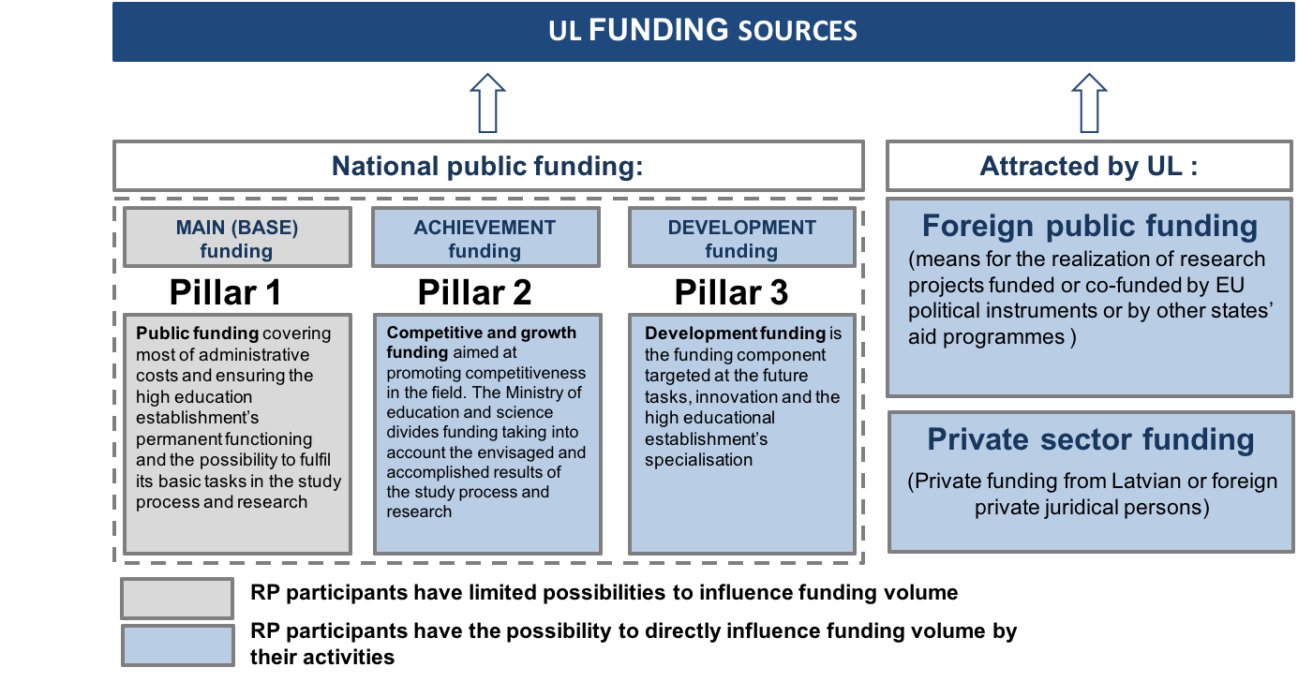

Figure 3. Research work funding sources at the University of Latvia

Objectives, their main indicators and values
The objectives for the next five years in the all research fields are divided according to the four development directions set by the University of Latvia:

1. scientific capacity and competitiveness;
2. alignment of research to economic needs and knowledge transfer;
3. human resources development;
4. promotion of international scientific cooperation.

All sector objectives and their operational performance indicators are summarized below (Table 1). These indicators are measured and the results are managed in accordance with the UL result management policies.

Table 1. The development directions, objectives, performance indicators and the expected value increase in all fields
1. Development direction | Development of scientific capacity and competitiveness | 2014 | 2020
Objective 1.1 | To increase the competitiveness in European space
R.1.1.1 | Scientific publications (including scientific articles in academic journals and articles in conference proceedings, chapters in monographs, conference proceedings publications, etc. inventory and other) in Web of Science and Scopus databases. | 422 | 1296
R.1.1.2 | Scientific articles with citation index at least 50% of the sector's average citation index. | 131 | 244
R.1.1.3 | The average citation level (H-Factor). | 13 | 15
R.1.1.4 | The number of interdisciplinary research projects in cooperation with other UL departments, and other institutions. | 34 | 47
R.1.1.5 | The number of interdisciplinary scientific publications in cooperation with other UL departments and other institutions. | 500 | 550
Objective 1.2 | To increase scientific capacity
R.1.2.1 | The number of scientific staff (leading researchers, researchers, research assistants). | 510 | 663
R.1.2.2 | The number of employed scientists. | 1026 | 1226
R.1.2.3 | Success indicator for membership in the European Union research and innovation programmes and technology initiatives within announced tenders (in %). | n.a. | 30%
R.1.2.4 | Total science funding (EUR). | 14 704 920 | 32 862 924

2. Development direction | Research relevance for economic needs and knowledge transfer | 2014 | 2020
Objective 2.1 | To increase the potential of knowledge transfer
R. 2.1.1 | Registered industrial property rights, using international, European or national application procedure in the following countries: Germany, Spain, United Kingdom, Denmark, Norway, Sweden, Finland, Estonia, Poland, the Czech Republic, Austria, Hungary, Romania, Russia, USA, Australia, Canada, India, Japan, People's Republic of China. | 26 | 98
R.2.1.2 | The number of implemented patents. | 0 | 10
R.2.1.3 | The number of intellectual property (technological rights) license agreements (LLA). | 0 | 10
R.2.1.4 | The number of spin-off companies. | 0 | 10
Objective 2.2 | To raise revenue from knowledge transfer
R.2.2.1 | Private sector funding (EUR). | 712 390 | 3 419 720
R.2.2.2 | Revenue from the transfer of intellectual property rights to business operators, public and other customers, for example, individuals, associations, foundations (EUR). | 0 | 30 000
R.2.2.3 | Funding (EUR) from contract research for enterprises, public persons, municipal and local governments. | 50 000 | 1 000 000
Objective 2.3 | To improve public understanding of scientific achievements
R.2.3.1 | The number of cooperation activities (joint projects) with the non-governmental sector. | 15 | 18
R.2.3.2 | The number of publications in print media reflecting the views of the UL scientists. | 20 | 25
R.2.3.3 | The data on UL staff participation in public administration and advisory institutions. | 283 | 300

3. Development direction | Human resources development | 2014 | 2020
Objective 3.1 | To promote the renewal of scientific staff
R.3.1.1 | The number of persons enrolled in doctoral study programmes. | 130 | 180
R.3.1.2 | The number of persons who have obtained the PhD degree or equivalent. | 102 | 130
R.3.1.3 | The number of persons who have obtained the PhD degree or equivalent and work at the UL. | 45 | 100
R.3.1.4 | The number of MA, PhD (or equivalent graduate level) students involved in research during the previous year, and new researchers who obtained the PhD degree or equivalent in the last 5 years. | 20 | 150
Objective 3.2 | To promote the development of research staff competence
R.3.2.1 | Research staff who attended professional development events (seminars, courses, training), their number in relation to the total number of research staff. | 2229/1026 | 2300/1226

4. Development direction | Promotion of international scientific cooperation
Objective 4.1 | To develop a network for international scientific cooperation
R.4.1.1 | The number of international research projects. | 35 | 69
R.4.1.2 | The number of international projects where the UL has the coordinating role (the beneficiary's status is coordinator). | 10 | 12
R.4.1.3 | The number of joint publications with foreign co-authors. | 225 | 287
R.4.1.4 | The number of international scientific conferences organized by the UL. | 33 | 50
Objective 4.2 | To increase the mobility of research staff
R.4.2.1 | The number of foreign scientific personnel who carried out research at the UL for at least one month. | 35 | 42
R.4.2.2 | The number of UL research staff who carried out research at foreign scientific institutions for at least one month. | 14 | 20

The Research Programme in Exact Sciences
The exact sciences research programme (RP) report (Report) comprises a summary of the objectives set by the University of Latvia (UL) for the period up to 2020, in the following fields:
• physics and materials engineering;
• chemistry and nanotechnology;
• computer and mathematical sciences;
• earth science, environmental science and environmental engineering industry.

The report contains information on the financial resources available in the future years, as well as on the research and innovation trends and the regulatory context. In addition, the RP level SWOT analysis has been performed to define a strategic framework for future actions (vision and mission), measurable objectives and targets to be achieved.
The report section "Areas of Excellence" sets research priorities for the coming years – these are the themes that are relevant to the public and have the highest potential to yield internationally significant scientific results and synergy in cooperation with other groups of sciences at the UL. In addition to the defined areas of excellence which indicate the total focus, the comprehensive RP includes specific research interests topical for exact sciences. To achieve the RP objectives, the performance indicators and indicator values are subordinated under four UL level development directions:

1. scientific capacity and competitiveness;
2. meeting economic research needs and providing knowledge transfer;
3. human resources development;
4. promotion of international scientific cooperation.
An action plan has been developed for each objecvtive, with detailed task descriptions, implementation time and the persons responsible.

Research and Development Trends in Latvia
In accordance with the fundamental objectives set by "Europe 2020": to invest 3% of EU GDP in research and development, Latvia has set a quantitative objective to increase research funding up to 1.5% of the GDP by 2020, but up to 3% of GDP by 2030. This scenario requires that national public research funding increases to 126.1 million EUR, private sector funding – up to 62.5 million EUR, while foreign public funds increase to 76.1 million EUR by the year 2020. The current Central Statistics Office data indicate that, compared to the year 2010, funding for research increased by 0.08 percent, corresponding to 0.68% of GDP in 2014, or 162.8 million EUR. This amount also includes 65.99 million EUR or 0.24% of GDP for research attracted by the higher education sector, of which 21.27 million EUR are the funding of exact sciences.
The exact sciences research sector in Latvia has witnessed a reduction in the number of scientific personnel; during the period from 2010 to 2013, the number of research personnel in this group decreased by 272 people or 24%. However, the number of researchers in exact sciences sector was 930 in 2014, which is about 8.2% more than the preceding year. Similar dynamics is also observed in this group of sciences at the UL. To solve the problem of inability to attract sufficient research staff, the human resources development plan is formulated in the RP.
The researchers from Latvia have an opportunity to participate in EU research and innovation support programmes from 2014 to 2020, including the EU research and innovation framework programme "Horizon 2020" (hereinafter referred to as "Horizon 2020"), which is the largest EU research and innovation programme providing nearly 80 billion EUR over seven years in addition to the private investments that will be attracted by the public funding. This programme has set three priorities:
1. "scientific excellence" (Excellent Science) (covers a range of European needs concerning the improvement of science and technology);
2. the "leading role in industrial production" (Industrial Leadership) (investment in key industrial technologies which ensure maximum development potential of European companies);
3. "public problem resolving" (Societal Challenges) (various priority topics, among which there are also health, demographic change and welfare).
The scientific staff within the framework of "Horizon 2020" may also participate in programmes such as, for example, "Science with and for Society” and COST (European Cooperation dans le Domaine de la recherche scientifique et technique).
The "Horizon 2020" framework envisages increased attention also to science-related industry areas in which the UL sciences have already some achievements, such as high-tech industry, new and future key technologies (nanotechnology, micro-and nano-electronics, photonics, advanced materials and production systems), as well as resolution of societal challenges related to climate changes, environment and efficient use of resources.
The priorities of “Horizon 2020” also partly coincide with the priorities designated by the Latvian Smart Specialisation Strategy for economic growth, such as high-value-added products, productive system of innovations, energy efficiency, advanced ICT, modern education, knowledge base and polycentric development. These priorities also correspond to the exact sciences -related smart specialization areas "intelligent materials, technology and engineering systems" and "information and communication technologies". The research programme of excellence in exact sciences and the research objectives of subsectors generally meet these priorities. When defining the UL research goals and objectives, the context of Latvia, the available research resources and realistic implementation possibilities must be taken into account. Similarly, for exact sciences and RPs in general, it is important to define ambitious, yet achievable goals.

Innovations: EU Innovation Index 2015

The EU innovation index 2015 (Innovation Union Scoreboard 2015) results show that the difference in innovation between the EU Member States continues to decline. The analysis of innovation issues points to positive trends among those countries where the level of innovation is below the EU average, including Latvia. On the other hand, the number of EU Member States with falling innovation index has risen sharply compared to 2014, apparently pointing to the effects of the economic crisis on science and innovation.
Latvia, Malta and Bulgaria are highlighted in the EC report as the countries with the fastest development of innovation during the period from 2007 to 2014. The Latvian innovation index in 2014 rose from 45% to 49%, but most of the value indicators of the index are still below the average EU level, particularly in relation to the number of co-publications which have resulted from cooperation with the private sector (public-private scientific co-publications), and revenue from patents and licenses abroad (3% and 7% at the EU level, respectively). The indicators of Latvia improved in two-thirds of the criteria in 2014 as compared to 2013, especially in the categories where the level of Latvia was lower than the EU average, such as Open, excellent and attractive research systems that showed 15% growth compared to 19% of the EU average) and Intellectual Assets, with 5.9% increase that was equal to 59% of the EU average level).
Based on the analysis, the leading international force for innovation in 2014 was South Korea, the United States and Japan, followed by the EU, Canada and Australia. The fastest development of innovations in 2014 was seen in South Korea (4.8%), the People's Republic of China (3.6%) and the EU (2.4%).

Research: global trends and challenges
Several global trends are currently observed in the field of scientific research. John Wood, Secretary General of the Association of Commonwealth universities, has underlined as one of the main research priorities in the global context, which is among the five major EC "Horizon 2020" program topics, the openness of Science ("Open Science") to the public, which includes the concept of free access to all information and the scientific pursuit of "Open Science for Open Innovation". These trends affect the global research space, and more and more pressure is expected to provide publicly funded research results and to increase data availability to the general public, which could ensure better links between science and innovation, promoting the further growth of global economy.
Given that currently the global scientific space is dominated by results-oriented environment, research evaluation criteria are increasingly important, which has also historically influenced research work. In today's changing environment, science becomes increasingly interdisciplinary, inter-institutional and internationally cooperative, raising the questions how to evaluate scientific publications with multiple co-authors and what would be the most appropriate influence factors and citation indices of publications. Consequently, the growing importance of institutional consortia and networking along with the traditional biometrics should be noted in the international scientific space. More and more often the tendency of large international organizations to participate in global research processes is observed, creating new patterns of cooperation in scientific activities and knowledge transfer.
In global scientific space, less importance is given to geographical boundaries; instead priority is given to scientific institutions in an integrated partnership with local or international governmental organizations and businesses, in order to jointly find innovative solutions to the challenges of global nature.

Strategic Framework

The research programme is subjected to the UL research development strategy 2015-2020, which determines the overall strategic framework of the RP and outlines the vision to build a national research university. For the implementation of the RP, specifically exact science’s group vision,, its mission and core values, as well as areas of excellence, which indicate the directions and the main focus of future activity till 2020 have been highlighted. In addition to these high profile areas of excellence, each faculty and scientific institute included in the RP, has developed specific priority research directions set out in the detailed version of the RP.

Vision

We want our research and innovations to become competitive in the European scientific space, promoting the visibility of UL sciences globally and contributing to the economic growth of Latvia.

Mission
We exist to explore questions essential for exact sciences, questions indispensable for Latvian economy, questions that have a high knowledge transfer and publication citation potential.

Core values
Our core values that we want to promote in research are excellence, creativity and openness.

Excellence
Exact sciences aim to promote the UL as a scientific centre of global significance, while providing research-based and innovative education.

Creativity

Exact sciences strive for the creation and utilization of new intellectual values in science, public health and welfare, as well for promoting innovative ideas in research.

Openness

Exact sciences in their activities are open and share expertise with individuals and the society, as well as with national, public and private sectors, promoting contribution of science to economic growth.
Exact sciences promote public access to research work of the academic community, actively participate in science communication projects and popularize the achievements of science and technology.

Areas of Excellence
The exact sciences group has identified several areas of excellence, taking into account both the potential of existing scientific achievements , and major trends, as well as expected available resources and research capacity. The areas of excellence (Figure 4), highlight the potential for cooperation with other scientific disciplines in respective research fields. In addition to these high profile areas of excellence, each faculty and scientific institute included in the RP, has developed specific priority research directions set out in the detailed version of the RP.

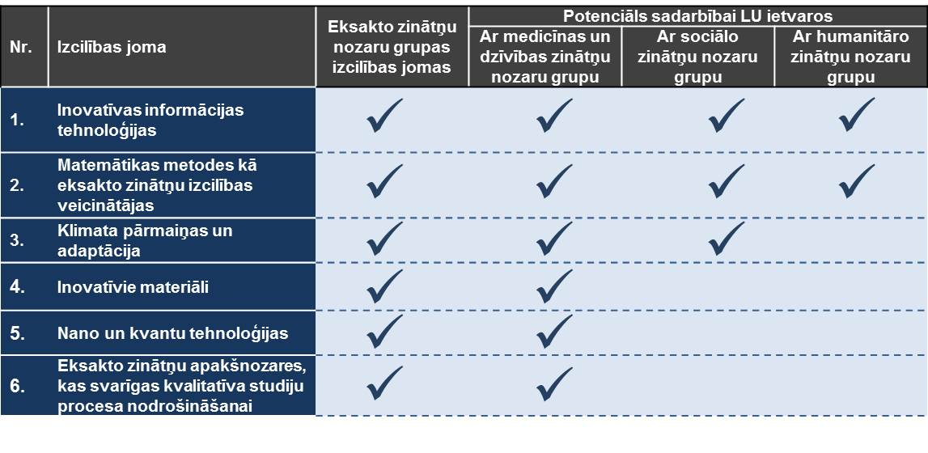
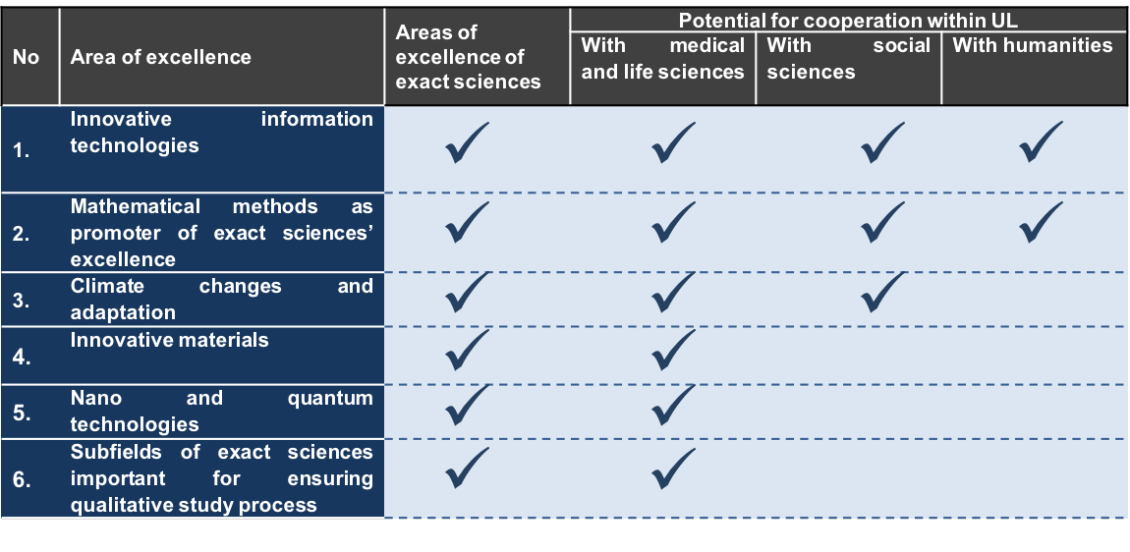
Figure 4. The areas of excellence of the exact sciences group and their research potential in cooperation with other groups of sciences

Several of the areas of excellence for interdisciplinary cooperation have the potential both in the UL and beyond. For example, cooperation is possible in the field of innovative information technology, as well as mathematical methods in exact sciences with most of other UL science fields. At the same time, climate change and adaptation research within the exact sciences have a potential for interdisciplinary cooperation with both social sciences and medical and life sciences.

Objectives, their main indicators and values
The objectives for the next five years in the field of exact sciences are divided according to the four development directions set by the University of Latvia:

1. scientific capacity and competitiveness;
2. alignment of research to economic needs and knowledge transfer;
3. human resources development;
4. promotion of international scientific cooperation.

The exact sciences sector objectives and their operational performance indicators are included in above Table 1. These indicators are measured and the results are managed in accordance with the UL result management policies.

Implementation plan and tasks

To reach the objectives, an institutional development and human resources development plan has been developed. Deadlines and responsibilities for each task have been identified (Table 2).

Table 2. RP implementation plan
Nr | Activity | Year
 |  | 2016 | 2017 | 2018 | 2019 | 2020
General objectives for the implementation of the research programme
1 | To develop and approve a detailed change management plan.
2 | To nominate change management team.
3 | To implement a change management plan with the aim of regularly monitoring the progress of implementation of the RP and to coordinate its implementation. .
1. Development direction - development of research capacity and research activity competitiveness in the European research space
Objective 1.1. To increase the research competitiveness of science groups in the European research space
4 | To define the evaluation approach to participation in international conferences, setting priority criteria for high level publications in scientific journals.
5 | To implement intersectoral cooperation planning measures at least once every 3 months, by exchanging information about projects or publications in which cooperation is possible, identifying the needs of each subsector and competencies that can benefit other sectors.
6 | To work out the approach for regular research quality evaluations (in addition to quantitative indicators), evaluating the project quality at all stages of the research cycle.
Objective 1.2. To increase the research capacity of the sector group
7 | To set up a council for evaluation/improvement of project applications, to ensure the quality of international Project applications (maintaining the UL reputation )
8 | To design a research projects identification, project preparation, implementation and completion system, providing administrative support to the scientific staff.
9 | To implement practical training and information/experience exchange at least once every six months for the preparation of research projects’ applications and implementation. To create an international scientific conference attendance support fund, providing funds as a matter of priority for conference attendance, participation in which will contribute to the scientific review of the number of publications.
10 | To create an international scientific conference attendance support fund, providing funds as a matter of priority for attending conferences, participation in which will contribute to the increase of scientific ratings.
2. Development direction - Research relevance for economic needs and knowledge transfer
Objective 2.1. To increase the knowledge transfer potential

11 | To develop an organisational/administrative support system for researchers performing contract work and for participation in tenders.
12 | To set up research laboratories/offices for research directions with the potential to provide services and ensure active communication on research trends, achievements, and the services offered (consultancy and applied research).
13 | Private sector involvement in the development of new study programmes or in improving existing programmes, with the potential to transfer knowledge and to attain internationally significant research potential.
Objective 2.2.To increase revenue from the transfer of knowledge

14 | To develop knowledge transfer strategies, with the aim of systematically fostering cooperation with economic operators in the sectors identified (such as private education, nursery, transport and educational services companies, travel companies, consulting companies, social partners, IT business environment, publishing houses, security systems, etc.).
15 | To create a service directory to identify the services that are provided for a fee and the services that can be provided free of charge, taking into account other considerations (e.g., visibility, publishing, promotion of cooperation).
16 | To identify the scientific areas in each subsector and to find potential clients for knowledge transfer for a fee.
17 | To develop an incentive funding model at the UL level so that the existing individual scientific research developed for clients can be a part of the UL activities.
Objective 2.3. To improve public awareness of scientific achievements

18 | To develop the process and UL support mechanisms for attracting contract work and dissemination of research results.
19 | To develop guidelines and define detailed activities for the UL experts voicing their views in the media in order to increase public awareness of the UL as a Research University and public understanding of research activities implemented at the UL and the results obtained.
3. Development direction – Human resources development
Objective 3.1. To promote the renewal of research personnel.
20 | To design and implement the UL remuneration and motivation model for UL academic staff and to improve the existing remuneration system.
21 | To develop a system for the performance evaluation and motivation of UL employees.
22 | Based on the employee job satisfaction surveys and the results of the doctoral students focus group, to create a joint working group of Personnel department and representatives of other structural units to decide on the solutions aimed at improving the UL workplace.
23 | To create a joint working group of the Personnel department and representatives from other structural units to agree on the evaluation criteria of the existing academic staff to promote gradual renewal of personnel.
24 | To introduce a succession system for academic staff.
Objective 3.2. To promote the development of scientific staff competencies
25 | To define the minimum required training and competency level for each post.
26 | To develop academic staff training plan aimed at improving the scientific capacity and better involvement in scientific capacity-building process.
27 | To link the professional development of employees and the training system with the performance evaluation system.
4. Development direction - Promotion of international scientific cooperation
Objective 4.1. To develop international scientific cooperation networks

28 | To develop scientific methodology/manual to facilitate scientific cooperation.
29 | To create a database of the existing and emerging international scientific institutions, working groups and individual researchers, in order to identify potential collaboration areas and to better assess the progress (the database is to be linked to the promotion of scientific cooperation methodology/manual).
30 | To develop individual and institutional arrangements for collaboration and contact network building and expansion.
31 | To define a support model for foreign visits by research staff and formulate a policy with the goal of promoting joint publications in international peer reviewed scientific journals.
Objective 4.2. To increase the mobility of research staff

32 | To create a communications strategy to update and expand the contact networks involving both individual employees and and institutions (internal and external communication).
33 | To popularise academic positions and promote study opportunities internationally through collaboration and contact networks.
34 | To hold international competitions for academic staff positions.
35 | To provide funding for individual and institutional cooperation and networking contacts in order to attract more foreign guest speakers, students and scientific personnel.

The Research Programme in the Medical and Life Sciences

The medical and life sciences research programme (RP) report (Report) includes a summary of the objectives set by the University of Latvia (UL) planned for the period till 2020, including the following fields:
• the biological, environmental, agricultural, industrial, and medical biotechnology and medical engineering fields;
• the medical and health sciences field.

The report contains information on the financial resources available in the future years, as well as on the research and innovation trends and the regulatory context. In addition, the RP level SWOT analysis has been carried out to define a strategic framework for future actions (vision and mission), measurable objectives, and targets to be achieved.
The report section "Areas of excellence" sets research priorities for the coming years – these are the themes that are relevant to the public and have the highest potential to yield internationally significant scientific results and provide synergy in cooperation with other groups of sciences at the UL. In addition to the defined areas of excellence which indicate the total RP focus, the advanced RP includes specific medical and life sciences sectors aligned with the current research topics. To achieve the RP objectives, the performance indicators and indicator values are subordinated under four UL level developments:
1. scientific capacity and competitiveness;
2. meeting commercial research needs and providing knowledge transfer;
3. human resources development;
4. promotion of international scientific cooperation.

An action plan has been worked out for each objective, complete with detailed task descriptions, implementation time, and the persons responsible.

Research and Development: Trends in Latvian Medical and Life Sciences

In accordance with the fundamental objectives set by "Europe 2020" – to invest 3% of EU GDP in research and development, Latvia has established a quantitative objective to increase research funding up to 1.5% of the GDP by 2020, and to 3% of GDP by 2030. This scenario requires that the state research funding in the public sector increases to 126.1 million EUR by the year 2020, private sector funding – to 62.5 million EUR, while the contribution from foreign public funds grows to 76.1 million EUR. The current Central Statistics Office data indicate that, compared to the year 2010, funding for research increased by 0.08 percent, corresponding to 0.68% of GDP or 162.8 million EUR in 2014. This amount also includes 65.99 million EUR or 0.24% of GDP for research attracted from the higher education sector, of which 12.81 million EUR constitutes funding for medical and life sciences.
The medical and life science research in Latvia has seen increase in the number of research staff - during the period from 2010 to 2012, the number of research personnel in the group increased by 126 people, or 63%. However, the number of researchers in medical and life sciences sectors has decreased gradually since 2012: the research staff in medical and life sciences group was 302 in 2013, while –decreasing to 285 in 2014. Similar dynamics was also observed in the medical and life sciences at the UL. To resolve this problem of inability to attract sufficient research staff, a human resources development plan was formulated in the RP.
The researchers from Latvia have an opportunity to participate in EU research and innovation support programmes from 2014 to 2020, including the EU research and innovation framework programme "Horizon 2020" (hereinafter referred to as "Horizon 2020"), which is the largest EU research and innovation programme providing nearly 80 billion EUR over 7 years, in addition to the private investments that will be attracted by this public funding. This programme has been focussed on three priorities:
1. "Scientific excellence" (Excellent Science) (covers a range of European needs concerning the improvement of science and technology);
2. The "leading role in industrial production" (Industrial Leadership) (investment in key industrial technologies which ensure maximum development potential of European companies);
3. "Public problem solving" (Societal Challenges) (various priority topics, among which there are also health, demographic change and wellbeing).
The scientific staff within "Horizon 2020" framework is also able to participate in programmes such as, for example, Science with and for Society and COST (European Cooperation dans le Domaine de la recherche scientifique et technique). "Horizon 2020" programmes are focused on increased attention to group-related areas where medical and life sciences of the UL have demonstrated good achievements, such as biotech and regenerative medicine, population dynamics and public health research.
The priorities of "Horizon 2020” also partly coincide with the priorities designated by the Latvian Smart Specialisation Strategy for economic growth, such as high value-added products, productive system of innovation, modern education, knowledge base, and polycentric development. These priorities also correspond to the medical and life sciences included in the smart specialisation field "biomedicine, medical technology, biopharmaceutical and biotechnology". The research programme of excellence in medical and life sciences and the research objectives of subsectors generally meet these priorities. For the UL research goals and objectives, the context of Latvia must be taken into account when defining the available resources and realistic implementation possibilities, for example, for the medical field it could mean to focus on the discovery/definition of new diagnostic approaches, as well as evaluation of new medicines rather than invention, for which no resources are envisaged in the coming years. Similarly, for life sciences and the RP in general, it is important to define ambitious, yet realistically achievable goals.

Innovation: EU innovation index 2015

The EU innovation index 2015 (Innovation Union Scoreboard 2015) results show that the difference in innovation between the EU Member States continues to decline. The analysis of innovation issues points to positive trends among those countries where the level of innovation is below the EU average, including Latvia. On the other hand, the number of EU Member States with falling innovation indices has risen sharply compared to 2014, apparently pointing to the effects of economic crisis on science and innovation.
Latvia, Malta, and Bulgaria are highlighted in the EC report as the countries with the fastest development of innovation during the period from 2007 to 2014. The Latvian innovation index in 2014 rose from 45% to 49%, but most of the value indicators of the index are still below the average EU level, particularly in relation to the number of co-publications which have resulted from cooperation with the private sector (public-private scientific co-publications) and revenue from patents and licenses abroad (3% and 7% at the EU level, respectively). The indicators of Latvia improved in two thirds of the criteria in 2014 as compared to 2013, especially in the categories where the level of Latvia was lower than the EU average, such as Open, excellent, and attractive research systems that showed 15% growth compared to 19% of the EU average) and Intellectual Assets, with 5.9% increase that was equal to 59% of the EU average level).
Based on the analysis, the leading international force for innovation in 2014 was South Korea, the United States, and Japan, followed by the EU, Canada, and Australia. The fastest innovation in 2014 was seen in South Korea (4.8%), the People's Republic of China (3.6%), and the EU (2.4%).

Research: global trends and challenges

Several global trends are currently observed in the field of scientific research. John Wood, Secretary General of the Association of Commonwealth universities, has underlined as one of the main research priorities in the global context, which is among the five major EC "Horizon 2020" program topics, the openness of Science ("Open Science") to the public, which includes the concept of free access to all the information and the scientific pursuit of "Open Science, Open Innovation ". These trends affect the global science space; more and more pressure is expected to provide publicly funded research results and to increase data availability to the general public, which could ensure better links between science and innovation, promoting further development of world economy.
Given that currently the global scientific space is dominated by results-oriented environment, research evaluation criteria are increasingly important, which also has historically influenced research work. In today's changing environment, science becomes increasingly interdisciplinary, inter-institutional and internationally cooperative, raising the questions how to evaluate scientific publications with multiple co-authors and what would be the most appropriate influence factors and citation indices of publications. Consequently, the growing importance of institutional consortia and networking along with the traditional bibliometrics should be noted in the international scientific space. More and more often the tendency of large international organizations participating in global research processes is observed, creating new patterns of cooperation in scientific activities and knowledge transfer.
In global scientific space, less importance is given to the geographical boundaries; instead priority is given to scientific institutions in an integrated partnership with local or international governmental organizations and businesses, in order to jointly find innovative solutions to challenges of global nature.

SWOT analysis
Over the last twenty years the University of Latvia has achieved significant progress, which has enhanced the development of medical and life sciences. However, the sector still has its weaknesses and threats that can jeopardize the success of the development of research in the future. Hence, the ongoing process of change must be continued, as the SWOT analysis shows below (Table 3).

Table 3. SWOT analysis of medical and life sciences sectors

Strengths | Weaknesses
In several areas, research is carried out at the world level. | The ageing process of high quality scientific personnel continues.
High quality research personnel. | Lack of knowledge and expertise in commercialization and intellectual property issues.
Scientific staff comprises researchers involved in policy making in the sector at the national level. | In some sectors of RP doctoral study programmes the requirements do not contribute to achieving excellence in scientific publication.
Strong network of international partners. | The greater part of the scientific staff is overloaded with work unrelated to research, thus the research capacity is reduced.
Developed infrastructure conforming to the requirements. | Relatively low levels of internal collaboration and networking.
Opportunities | Threats
Scientific academic Centre (in Torņakalns) will open up opportunities for increasing interdisciplinary cross-sectoral research and innovation. | Unstable local funding increases the dependence on EU structural funds.
Opportunities to increase cooperation with the Green incubator, other technology incubators, competence centres and research clusters. | Uncertainty, inconsistency and unpredictability are observed in the local healthcare industry.
Considerable research capacity increase is observed due to the increase of PhD students and completed PhD papers. | Emigration contributes to the shortage of younger scientists.
Latvian historical and spatial location, experience and contacts between Central Europe on the one hand, and the CIS, Central Asian and Eastern countries, on the other hand, opens up opportunities for international networking in science. | Insufficient amount of funding for doctoral scholarships, which prevents doctoral students from devoting full time to their doctoral work and does not contribute to achieving excellence.
Foreign researchers’ interest to both vacancies in post-graduate studies and researcher positions. | Latvia has few traditions of cross-sectoral cooperation, which creates the burden of bureaucratic requirements and doubling of institutional functions in the system.

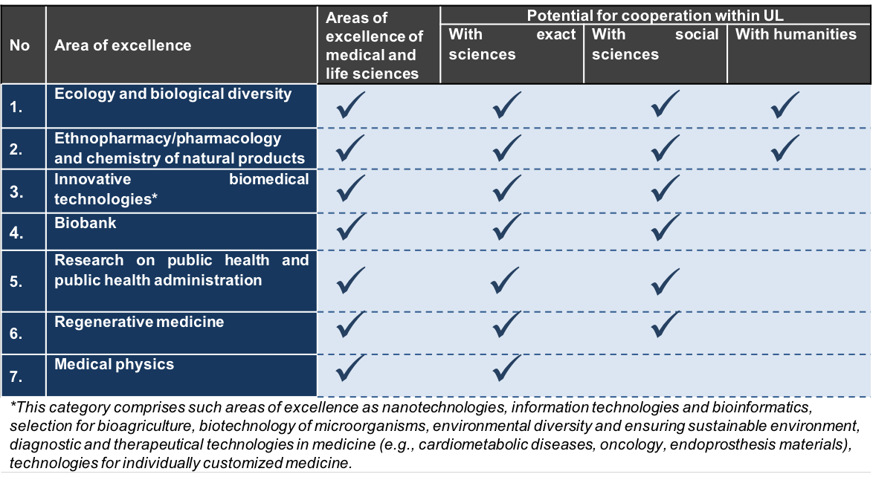Figure 5. Areas of excellence in medical and life sciences and their research potential in cooperation with other fields.

Several of the areas of excellence for interdisciplinary cooperation have the potential both in the UL and beyond. For example, cooperation is possible in the field of ecology and biodiversity with most of the other UL science fields. At the same time, medical and life sciences, and innovative biomedical technologies have a potential for interdisciplinary cooperation with both the exact sciences and social sciences.

Objectives, their main indicators and values
The objectives for the next five years in the field of medical and life sciences are divided according to the four development directions set by the University of Latvia:

1. scientific capacity and competitiveness;
2. alignment of research to economic needs and knowledge transfer;
3. human resources development;
4. promotion of international scientific cooperation.

The medical and life sciences sector objectives, as well as their operational performance indicators are included in the above Table 1. It should be taken into account that the results of medical and life sciences RP implementation will be not only directly measurable by the indicators listed in Table 1 below, but also by the provided socio-economic benefits (e.g., improvements in public health will have indirect economic benefits), and their evaluation will require additional assessment. These indicators are measured and the results are managed in accordance with the UL result management policies.

Implementation plan and tasks
In order to reach the objectives, an institutional development and human resources development plan has been worked out. Deadlines and responsibilities for each task have been identified (Table 4).

Table 4. RP implementation plan

Nr | Activity | Year
 |  | 2016 | 2017 | 2018 | 2019 | 2020
General objectives for the implementation of the research programme
1 | To develop and approve a detailed change management plan.
2 | To nominate change management team.
3 | To implement a change management plan with the aim of regularly monitoring the progress of implementation of the RP and to coordinate its implementation.
1. Development direction - development of research capacity and research activity competitiveness in the European research space
Objective 1.1. Increasing the research competitiveness of science groups in the European research space
4 | To define the evaluation approach to participation in international conferences. Setting priority criteria for high level publications in scientific journals.
5 | To implement intersectoral cooperation planning measures at least once every 3 months by exchanging information about projects or publications in which cooperation is possible, identifying the needs of each subsector and competencies that can benefit other sectors.
6 | To work out the approach for regular research quality evaluations (in addition to quantitative indicators), evaluating the project quality at all stages of the research cycle.
Objective 1.2. To increase the research capacity of the sector group
7 | To set up a council for evaluation/improvement of project applications, to ensure the quality of international Project applications (maintaining the UL reputation).
8 | To design a research projects identification, project preparation, implementation and completion system, providing administrative support to the scientific staff.
9 | To implement practical training and information/experience exchange at least once every six months for the preparation of research projects applications.
10 | To create an international scientific conference attendance support fund, providing funds as a matter of priority for attending conferences, participation in which will contribute to the increase of scientific ratings.
2. Development direction - Research relevance for economic needs and knowledge transfer
Objective 2.1. To increase the knowledge transfer potential

11 | To develop an organisational/administrative support system for researchers performing contract work and for participation in tenders.
12 | To set up research laboratories/offices for research directions with the potential to provide services and ensure active communication on research trends, achievements, and the services offered (consultancy and applied research).
13 | Private sector involvement in the development of new study programmes or in improving existing programmes, with the potential to transfer knowledge and to attain internationally significant research potential.
Objective 2.2. Increase revenue from the transfer of knowledge

14 | To develop knowledge transfer strategies, with the aim of systematically fostering cooperation with economic operators in the sectors identified (such as private education, nursery, transport and educational services companies, travel companies, consulting companies, social partners, IT business environment, publishing houses, security systems, etc.).
15 | To create a service directory to identify the services that are provided for a fee and the services that can be provided free of charge, taking into account other considerations (e.g., visibility, publishing, promotion of cooperation).
16 | To identify the scientific areas in each subsector and to find potential clients for knowledge transfer for a fee.
17 | To develop an incentive funding model at the UL level so that the existing individual scientific research developed for clients can be part of the UL activities.
Objective 2.3. To improve public awareness of scientific achievements

18 | To develop the process and UL support mechanisms for attracting contract work and dissemination of research results.
19 | To develop guidelines and define detailed activities for the UL experts voicing their views in the media in order to increase public awareness of the UL as a Research University and public understanding of research activities implemented at the UL and the results obtained.
3. Development direction – Human resources development
Objective 3.1. Promote the renewal of research personnel.
20 | To design and implement the remuneration and motivation model for UL academic staff and to improve the existing remuneration system.
21 | To develop a system for the performance evaluation and motivation of UL employees.
22 | Based on the employee job satisfaction surveys and the results of the doctoral student focus group, to create a joint working group of the Personnel department and representatives from other structural units to decide on the solutions aimed at improving the UL workplace.
23 | To create a joint working group of the Personnel department and representatives from other structural units to agree on the evaluation criteria of the existing academic staff to promote gradual renewal of personnel.
24 | To introduce a succession system for academic staff.
Objective 3.2. To promote the development of scientific staff competencies
25 | To define the minimum required training and competency level for each post.
26 | To develop academic staff training plan aimed at improving the scientific capacity and better involvement in scientific capacity-building process.
27 | To link the professional development of employees and the training system with the performance evaluation system.
4. Development direction - Promotion of international scientific cooperation
Objective 4.1. To develop international scientific cooperation networks

28 | To develop scientific methodology/manual to facilitate scientific cooperation.
29 | To create a database of the existing and emerging international scientific institutions, working groups, and individual researchers, in order to identify potential collaboration areas and to better assess the progress (the database is to be linked to the promotion of scientific cooperation methodology/manual).
30 | To develop individual and institutional arrangements for collaboration and contact network building and expansion.
31 | To define a support model for foreign visits by research staff and formulate a policy with the goal of promoting joint publications in international peer reviewed scientific journals.
Objective 4.2. Increase the mobility of research staff

32 | To create a communications strategy to update and expand the contact networks involving both individual employees and institutions (internal and external communication).
33 | To popularise academic positions and promote study opportunities internationally through collaboration and contact networks.
34 | To hold international competitions for academic staff positions.
35 | To provide funding for individual and institutional cooperation and networking contacts in order to attract more foreign guest speakers, students, and scientific personnel.

The Research Programme in Social Sciences and Law
The social sciences and law research programme (RP) report (Report) includes a summary of the objectives set by the University of Latvia (UL) planned for the period till 2020, including the following fields:

- economics and business;
- educational sciences and psychology;
- law;
- political science, media and communications;
- social and economic geography, and other social sciences.

The report contains information on the financial resources available in the future years, as well as on the research and innovation trends and the regulatory context. In addition, the RP level SWOT analysis has been carried out to define a strategic framework for future actions (vision and mission), measurable objectives, and targets to be achieved.
The report section "Areas of excellence" sets research priorities for the coming years – these are the themes that are relevant to the public and have the highest potential to yield internationally significant scientific results and provide synergy in cooperation with other groups of sciences at the UL. In addition to the defined areas of excellence which indicate the total RP focus, the advanced RP includes specific social sciences sectors aligned with the current research topics. To achieve the RP objectives, the performance indicators and indicator values are subordinated under four UL level developments:

1. scientific capacity and competitiveness development;
2. meeting commercial research needs and providing knowledge transfer;
3. human resources development;
4. promotion of international scientific cooperation.

An action plan has been worked out for each objective, complete with detailed task descriptions, implementation time, and the persons responsible.

Research and Development: Trends in Social Sciences and Law Studies in Latvia

In accordance with the fundamental objectives set by "Europe 2020" – to invest 3% of EU GDP in research and development, Latvia has established a quantitative objective to increase research funding up to 1.5% of the GDP by 2020, and to 3% of GDP by 2030. This scenario requires that the state research funding in the public sector increases to 126.1 million EUR by the year 2020, private sector funding – to 62.5 million EUR, while the contribution from foreign public funds grows to 76.1 million EUR. The current Central Bureau of Statistics data indicate that, compared to the year 2010, funding for research increased by 0.08 percentcorresponding to 0.68% of GDP or 162.8 million EUR in 2014. This amount also includes 65.99 million EUR or 0.24% of GDP for research attracted from the higher education sector, of which 5.67 million EUR constitutes funding social sciences.

The social sciences research sector in Latvia has witnessed a reduction in the number of research personnel - during the period from 2011 to 2014, the number of researchers in this group decreased by 199 people, or 29,26%. The number of research staff in social sciences in the year 2014 was 481, which is the lowest in the last five years. Similar dynamics was observed in social sciences at the UL. To resolve this problem of inability to attract sufficient research staff, a human resources development plan was formulated in the RP.
The researchers from Latvia have the opportunity to participate in EU research and innovation support programmes from 2014 to 2020, including the EU research and innovation framework programme "Horizon 2020" (hereinafter referred to as "Horizon 2020"), which is the largest EU research and innovation programme providing nearly 80 billion EUR over 7 years, in addition to the private investments that will be attracted by this public funding. This programme has been focused on three priorities:
1. "Scientific excellence" (Excellent Science) (covers a range of European needs concerning the improvement of science and technology);
2. The "leading role in industrial production" (Industrial Leadership) (investment in key industrial technologies which ensures maximum development potential of European companies);
3. "Public problem resolving" (Societal Challenges) (various priority topics, among which there are also health, demographic change and welfare).
The scientific staff within "Horizon 2020" framework is also able to participate in programmes such as Science with and for Society and COST (European Cooperation dans le Domaine de la recherche scientifique et technique).
"Horizon 2020" is based on interdisciplinary and international cooperation for global problem-solving, not limited to a particular field. Consequently, almost all of the priority research strands in "Horizon 2020" also include the perspective jointly adopted by humanities and social sciences. "Horizon 2020" programmes are focused on increased attention to group-related areas where social sciences of the UL have demonstrated good achievements, for example, public welfare and human resources development, bioeconomics, research on issues related to migration and integration challenges within Europe, issues related to the effective management of institutions and processes.
The priorities of "Horizon 2020” also coincide with the priorities designated by the Latvian Smart Specialisation strategy for economic growth, such as high value-added products, productive system of innovation, modern education, knowledge base and polycentric development. These priorities also correspond to the social sciences-related smart specialisation field "Knowledge-intensive bioeconomy", which within the context of Smart Specialisation Strategy and "Horizon 2020" comprises such topics as food security, sustainable management of natural resources, reduction of dependence on non-renewable resources, climate change mitigation and adaptation to the changes, maintaining European competitiveness through concerted economic activity, participation in governance and social dialogue. In addition, social sciences are closely invooved in the assurance of the knowledge base, as well as educational excellence and quality.

Innovation: EU innovation index 2015

The EU innovation index 2015 (Innovation Union Scoreboard 2015) results show that the difference in innovation between the EU Member States continues to decline. The analysis of innovation issues points to positive trends among those countries where the level of innovation is below the EU average, including also Latvia. On the other hand, the number of EU Member States with falling innovation indices has had risen sharply compared to 2014, apparently pointing to the effects of economic crisis on science and innovation
Latvia, Malta, and Bulgaria are highlighted in the EC report as the countries with the fastest development of innovation during the period from 2007 to 2014. The Latvian innovation index in 2014 rose from 45% to 49%, but most of the value indicators of the index are still below the average EU level, particularly in relation to the number of co-publications which have resulted from cooperation with the private sector (public-private scientific co-publications) and revenue from patents and licenses abroad (3% and 7% at the EU level, respectively). The indicators of Latvia improved in two thirds of the criteria in 2014 as compared to 2013, especially in the categories where the level of Latvia was lower than the EU average, such as Open, excellent, and attractive research systems that showed 15% growth compared to 19% of the EU average) and Intellectual Assets, with 5.9% increase that was equal to 59% of the EU average level)
Based on the EC analysis, the leading international force for innovation in 2014 was South Korea, the United States and Japan, followed by the EU, Canada and Australia. The fastest innovations development in 2014 was in South Korea (4.8%), the People's Republic of China (3.6%) and the EU (2.4%).

Research: global trends and challenges

Several global trends are currently observed in the field of scientific research. John Wood, Secretary General of the Association of Commonwealth universities, has underlined as one of the main research priorities in the global context, which is among the five major EC "Horizon 2020" programme topics, the openness of science ("Open Science") to the public, which includes the concept of free access to all the information and the scientific pursuit of "Open Science for Open Innovation". These trends affect the global science space; more and more pressure is expected to provide publicly funded research results and data availability to the general public, which could ensure better links between science and innovation, promoting further development of world economy.
Given that currently the global scientific space is dominated by results-oriented environment, research evaluation criteria are increasingly important, which also has historically influenced research work. In today's changing environment science becomes increasingly interdisciplinary, inter-institutional and internationally cooperative, raising the questions how to evaluate scientific publications with multiple co-authors and what would be the most appropriate influence factors and citation indices of the publications. Consequently, the growing importance of institutional consortia and networking along with the traditional bibliometrics should be noted in the international scientific space. More and more often the tendency of large international organizations participating in global research processes is observed, creating new patterns of cooperation in scientific activities and knowledge transfer.
In global scientific space, less importance is given to geographical boundaries; instead priority is given to scientific institutions in an integrated partnership with local or international governmental organizations and businesses, in order to jointly find innovative solutions to the challenges of global nature.

SWOT analysis
Over the last twenty years, the University of Latvia has achieved significant progress, which has enhanced the development of social sciences. However, the sector still has its weaknesses and threats that can jeopardize the success of the development of research in the future. Hence, the ongoing process of change must be continued, as it is shown in the SWOT analysis below (Table 5).

Table 5. SWOT analysis of Social sciences and law sector

SWOT analysis
Strengths | Weaknesses
Research has supportive and well-developed infrastructure. | On the whole, weak scientific results at the international level (citation index); not all publications are of high quality.
The ability to provide high-quality, full-cycle research for the society. | There is no centralised motivation system for UL research scientific activities (projects, publishing, work loads, etc.) that would promote research work.
The research staff comprises internationally known researchers. | Insufficient knowledge of foreign languages (for the creation of academic texts in foreign languages).
Strong networks established with some fields in the framework of interdisciplinary research. | High average age of the employees and insufficient generational replacement.
Access to scientific publications databases conforms to the requirements. | Insufficient access to databases to obtain data and statistical data.
Opportunities | Threats
External financing for research, research-funded international research projects (for example, "Horizon 2020). | Pay for research based on projects only creates insecurity for the staff.
Developed individual and institutional networks, also with other researchers, with employers and businesses. | Academic staff has limited possibilities for research, given big teaching work loads.
Students are interested in graduate studies, as well as post-doctoral research. | The general demographic situation in the country and the decline in student numbers threatens the financial stability of faculty research.
The research-studies link has the potential to generate excellent study programmes, to which new knowledge obtained in research would contribute. | Social sciences are positioned in the negative light in the society and are linked to overproduction of specialists, especially in some subfields.

Strategic framework

The research programme is subjected to the UL research activities development strategy 2015-2020, which determines the overall strategic framework of the RP and outlines the vision to build a national research university. For the implementation of the RP, specifically social sciences group vision, its mission and core values, as well as areas of excellence, which indicate the direction of the work and the main focus of future activity till 2020 have been highlighted. In addition to these high profile areas of excellence, each of the faculties and scientific institutes included in the RP, has developed specific priority research directions set out in the detailed version of the RP.
.

Vision

Shaping the model of the national research university, we want our research to become competitive in the European research space, raising the visibility of the UL science sector in the Baltics and globally and contributing to the societal and economic development of Latvia.

Mission
We exist to explore important questions in the domain of social sciences, questions essential for Latvian economy that have a high knowledge transfer and publication citation potential.

Core values
Our core values that we want to promote in research are excellence, creativity and openness.

Excellence

Social sciences aim to promote the UL as a scientific centre of global significance, while providing research-based and innovative education.

Creativity

Social sciences strive for the creation and utilization of new intellectual values in science, social and economic development, as well as for promoting of innovative ideas in research.

Openness
Social sciences in their activities are open and share their expertise with individuals and the society, as well as with national, public and private sectors, promoting contribution of science to economic growth.
Social sciences support public access to research work of the academic community, actively participate in science communication projects and promote the achievements of social sciences.

Areas of Excellence
Social sciences have identified several areas of excellence, taking into account both the research potential of existing scientific achievements, the major trends in the field and the expected available resources and research capacity. The areas of excellence (Figure 6) demonstrate the potential for cooperation with other scientific disciplines in respective research fields. In addition to these high profile areas of excellence, each faculty and scientific institute included in the RP, has developed specific priority research directions set out in the detailed version of the RP

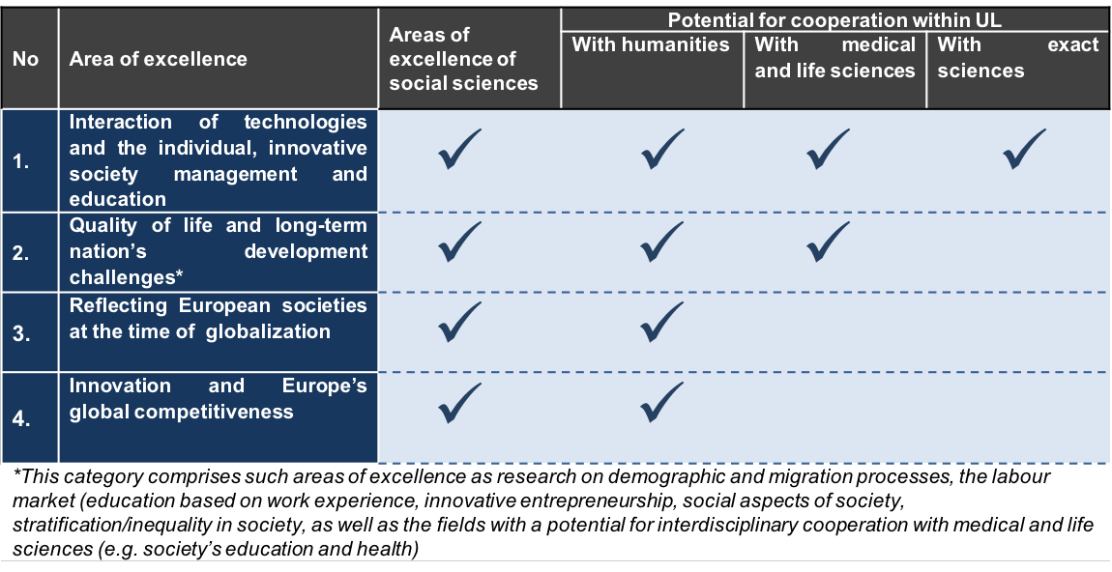

Figure 6. Areas of excellence in social sciences and law and their research potential in cooperstion with other groups of sciences.

Several of the areas of excellence for interdisciplinary cooperation have the potential in the UL and beyond. For example, social sciences can cooperate in the field of technology transfer, education, and community management with most of UL science fields. At the same time, sciences dealing with sustainable society and human resources development and quality of life have a potential for interdisciplinary collaboration both with humanities and individual sectors of exact, medical and life sciences.
Objectives, their main indicators and values
The objectives for the next five years in the field of social sciences are divided according to the four development directions set by the University of Latvia:

1. scientific capacity and competitiveness;
2. alignment of research to economic needs and knowledge transfer;
3. human resources development;
4. promotion of international scientific cooperation.

The social sciences sector objectives, as well as their operational performance indicators are included in the above Table 1. These indicators are measured and the results are managed in accordance with the UL result management policies.

Implementation plan and tasks
To reach the objectives, an institutional development and human resources development plan has been worked out. Deadlines and responsibilities for each task have been identified (Table 6).

Table 6. RP implementation plan
Nr | Activity | Year
 |  | 2016 | 2017 | 2018 | 2019 | 2020
General objectives for the implementation of the research programme
1 | To develop and approve a detailed change management plan.
2 | To nominate change management team.
3 | To implement a change management plan with the aim of regularly monitoring the progress of implementation of the RP and to coordinate its implementation. .
1. Development direction - development of research capacity and research activity competitiveness in the European research space
Objective 1.1. To increase the research competitiveness of the respective science group in the European research space
4 | To define the evaluation approach to participation in international conferences and set priority criteria for high level publications in scientific journals.
5 | To implement intersectoral cooperation planning measures at least once every 3 months, to by exchanging information about projects or publications in which cooperation is possible, identifying the needs of each subsector and competencies that can benefit other sectors.
6 | To work out the approach for regular research quality evaluation (in addition to quantitative indicators), evaluating the project quality at all stages of the research cycle.
Objective 1.2. To increase the research capacity of the sector group
7 | To set up a council for evaluation/improvement of project applications, to ensure the quality of international Project applications (maintaining the UL reputation).
8 | To design a a research projects identification, project preparation, implementation and completion system, providing administrative support to the scientific staff.
9 | To implement practical training and information/experience exchange at least once every six months for the preparation of research projects applications.
10 | To create an international scientific conference attendance support fund, providing funds as a matter of priority for attending conferences, participation in which will contribute to the increase of scientific ratings.
2. Development direction Research relevance for economic needs and knowledge transfer
Objective 2.1. To increase the knowledge transfer potential

11 | To develop an organizational/administrative support system for researchers performing contract work and for participation in tenders
12 | To set up research laboratories/offices for research directions with the potential to provide services and ensure active communication on research trends, achievements and the services offered (consultancy and applied research).
13 | Private sector involvement in the development of new study programmes or in improving existing programmes, with the potential to transfer knowledge and to attain internationally significant research potential.
Objective 2.2. To increase revenue from the transfer of knowledge

14 | To develop knowledge transfer strategies, with the aim of systematically fostering cooperation with economic operators in the sectors identified (such as private education, nursery, transport and educational services companies, travel companies, consulting companies, social partners, IT business environment, publishing houses, security systems, etc.).
15 | To create a service directory to identify the services that are provided for a fee and the services that can be provided free of charge, taking into account other considerations (e.g., visibility, publishing, promotion of cooperation).
16 | To identify the scientific areas in each subsector and to find potential clients for knowledge transfer for a fee.
17 | To develop an incentive funding model at the UL level so that the existing individual scientific research developed for clients can be a part of the UL activities.
Objective 2.3. To improve public awareness of scientific achievements

18 | To develop the process and UL support mechanisms for attracting contract work and dissemination of research results.
19 | To develop guidelines and define detailed activities for UL experts voicing their views in the media in order to increase public awareness of the UL as a Research University and public understanding of research activities implemented at the UL and the results obtained.
3. Development direction – Human resources development
Objective.1. To promote the renewal of research personnel.
20 | To design and implement the remuneration and motivation model for UL academic staff and to improve the existing remuneration system.
21 | To develop a system for the performance evaluation and motivation of UL employees.
22 | Based on the employee job satisfaction surveys and the results of the doctoral student focus group, to create a joint working group of the Personnel department and representatives from other structural units to decide on the solutions aimed at improving the UL workplace.
23 | To create a joint working group of the Personnel department and representatives from other structural units to agree on the evaluation criteria of the existing academic staff to promote gradual renewal of personnel.
24 | To introduce a succession system for academic staff
Objective 3.2. To promote the development of scientific staff competencies
25 | To define the minimum required training and competency level for each position.
26 | To develop academic staff training plan aimed at improving the scientific capacity and better involvement in scientific capacity-building process.
27 | To link the professional development of employees and the training system with the performance evaluation system.
4. Development direction - Promotion of international scientific cooperation
Objective 4.1. To develop international scientific cooperation networks

28 | To develop scientific methodology/manual to facilitate scientific cooperation.
29 | To create a database of the existing and emerging international scientific institutions, working groups and individual researchers, in order to identify potential collaboration areas and to better assess the progress (the database is to be linked to the promotion of scientific cooperation methodology/manual).
30 | To develop individual and institutional arrangements for collaboration and contact network building and expansion.
31 | To define a support model for foreign visits by research staff and formulate a policy with the goal of promoting joint publications in international peer reviewed scientific journals.
Objective 4.2. Increase the mobility of research staff

32 | To create a communications strategy to update and expand the contact networks involving both individual employees and institutions (internal and external communication)
33 | To popularize academic positions and promote studies opportunities internationally through collaboration and contact networks
34 | To hold international competitions for academic staff positions.
35 | To provide funding for individual and institutional cooperation and networking contacts in order to attract more foreign guest speakers, students and scientific personnel

The Research Programme in Humanities and Education

The humanities research programme (RP) report (Report) includes a summary of the objectives set by the University of Latvia (UL) planned for the period until 2020, including the following fields:
- philosophy, ethics and religion studies;
- language, literature and arts studies;
- history and archaeology

The report contains information on the financial resources available in the future years, as well as on the research and innovation trends and the regulatory context. In addition, the RP level SWOT analysis has been carried out to define a strategic framework for future actions (vision and mission), measurable objectives, and targets to be achieved.
The report section "Areas of excellence" sets research priorities for the coming years – these are the themes that are relevant to the public and have the highest potential to yield internationally significant scientific results and provide synergy in cooperation with other groups of sciences at the UL. In addition to the defined areas of excellence which indicate the total RP focus, the advanced RP includes specific research areas aligned with the current research topics in humanities.
To achieve the RP objectives, the performance indicators and indicator values are subordinated under four UL level developments:

1. scientific capacity and competitiveness development;
2. meeting commercial research needs and providing knowledge transfer;
3. human resources development;
4. promotion of international scientific cooperation.

An action plan has been worked out for each objective, complete with detailed task descriptions, implementation time, and the persons responsible.

Research and Development: Trends in Humanities in Latvia

In accordance with the fundamental objectives set by "Europe 2020" – to invest 3% of EU GDP in research and development, Latvia has established a quantitative objective to increase research funding up to 1.5% of the GDP by 2020, and to 3% of GDP by 2030. This scenario requires that the state research funding in the public sector increases to 126.1 million EUR by the year 2020, private sector funding – to 62.5 million EUR, while the contribution from foreign public funds grows to 76.1 million EUR. The current Central Statistics Board data indicate that, compared to the year 2010, funding for research increased by 0.08 percent, corresponding to 0.68% of GDP or 162.8 million EUR in 2014. This amount also includes 65.99 million EUR or 0.24% of GDP for research attracted from the higher education sector, of which 4,39 million EUR constitutes funding for the humanities sector.
The humanities research sector in Latvia has seen a reduction in the number of research staff - during the period from 2011 to 2014, the number of research personnel in this group decreased by 79 people, or 18,81%. In 2014, the number of employees employed in the group of humanities within the the higher education sector was 341, which is the lowest number in the last five years. Similar dynamics is also observed in the field of humanities at the UL. To resolve this problem of inability to attract sufficient research staff, a human resources development plan was formulated in the RP.
The researchers from Latvia have an opportunity to participate in EU research and innovation support programmes from 2014 to 2020, including the EU research and innovation framework programme "Horizon 2020" (hereinafter referred to as "Horizon 2020"), which is the largest EU research and innovation programme providing nearly 80 billion EUR (including 17 million in 1016 – 2017) over 7 years, in addition to the private investments that will be attracted by this public funding. This programme has set three priorities:

1. "Scientific excellence" (Excellent Science) (covers a range of European needs concerning the improvement of science and technology);
2. The "leading role in industrial production" (Industrial Leadership) (investment in key industrial technologies which ensure maximum development potential of European companies);
3. "Public problem resolving" (Societal Challenges) (various priority topics, among which there are also health, demographic change and welfare).
The scientific staff within "Horizon 2020" framework is also able to participate in such programmes as, Science with and for Society and COST (European Cooperation dans le Domaine de la recherche scientifique et technique).

"Horizon 2020" is based on interdisciplinary and international cooperation for global problem-solving, not limited to a particular research field. Consequently, almost all of the priority research themes in "Horizon 2020" also include the perspective jointly adopted by humanities and social sciences. Priority directions include the topics in which the UL social sciences already have achievements, for example, critical thinking development in European society.
The priorities of "Horizon 2020” also partly coincide with the priorities designated by the Latvian Smart Specialisation Strategy for economic growth, such as modern information and communication technologies, modern education, knowledge base development. While humanities are not directly defined as one of smart specialization fields, indirectly they have a significant role in such specialization fields as "knowledge-intensive bioeconomy", biotechnology, smart materials and energy production and development, for their contribution can ensure the readiness of the society to understand and accept innovative solutions. Humanities also have good achievements in research the context of which is related to such economy development priorities as modern information and communication technologies, modern education, and knowledge base development.

Innovation: EU innovation index 2015

The EU innovation index 2015 (Innovation Union Scoreboard 2015) results show that the difference in innovation between the EU Member States continues to decline. The analysis of innovation issues points to positive trends among those countries where the level of innovation is below the EU average, including Latvia. On the other hand, the number of EU Member States with falling innovation indices had has risen sharply compared to 2014, apparently pointing to the effects of economic crisis on science and innovation.
Latvia, Malta and Bulgaria are highlighted in the EC report as the countries with the fastest development of innovation during the period from 2007 to 2014. The Latvian innovation index in 2014 rose from 45% to 49%, but most of the value indicators of the index are still below the average EU level, particularly in relation to the number of co-publications which have resulted from cooperation with the private sector (public-private scientific co-publications), and to revenue from patents and licenses abroad (3% and 7% at the EU level, respectively). The indicators of Latvia improved in two thirds of the criteria in 2014 as compared to 2013, especially in the categories where the level of Latvia was lower than the EU average, such as Open, excellent, and attractive research systems that showed 15% growth compared to 19% of the EU average) and Intellectual Assets, with 5.9% increase that was equal to 59% of the EU average level)..
Based on the EC analysis, the leading international force for innovation in 2014 was South Korea, the United States and Japan, followed by the EU, Canada and Australia. The fastest innovations development in 2014 was seen in South Korea (4.8%), the People's Republic of China (3.6%) and the EU (2.4%).

Research: global trends and challenges
Several global trends are currently observed in the field of scientific research. John Wood, Secretary General of the Association of Commonwealth universities, has underlined as one of the main research priorities in the global context, which is among the five major EC "Horizon 2020" program topics, the openness of science ("Open Science") to the public, which includes the concept of free access to all the information and the scientific pursuit of "Open Science for Open Innovation ".These trends affect the global science space, more and more pressure is expected to provide publicly funded research results and to increase data availability to the general public, which could ensure better links between science and innovation, promoting further development of world economy.
Given that currently the global scientific space is dominated by a results-oriented environment, research evaluation criteria are increasingly important, which also has historically influenced research work. In today's changing environment science becomes increasingly interdisciplinary, inter-institutional and internationally cooperative, raising the questions how to evaluate scientific publications with multiple co-authors and what would be the most appropriate influence factors and citation indices of publications. Consequently, the growing importance of institutional consortia and networking along with the traditional bibliometrics should be noted in the international scientific space. More and more often the tendency of large international organizations participating in global research processes is observed, creating new patterns of cooperation in scientific activities and knowledge transfer.
In global scientific space less importance is given to the geographical boundaries; instead priority is given to scientific institutions in an integrated partnership with local or international governmental organizations and businesses, in order to jointly find innovative solutions to the challenges of global nature.

SWOT analysis
Over the last twenty years the University of Latvia has achieved significant progress, which has enhanced the development of humanities. However, the sector still has its weaknesses and threats that can jeopardize the success of the development of research in the future. Hence, the ongoing process of change must be continued, as the SWOT analysis shows below (Table 7).

Table 7. SWOT analysis
Humanities SWOT analysis
Strengths | Weaknesses
Leading and driving force in Latvia in the field of humanities. | Relatively small number of students.
Highly qualified academic and research personnel, including scholars with the international academic reputation. | Ageing of academic personnel.
In some fields world-class research is carried out. | Relatively low number of co-publications.
Technical (infrastructure) meets requirements. | Academic staff devote more time to teaching than to research.
Access to a wide range of databases. | Sporadic knowledge transfer, often free of charge
Opportunities | Threats
Humanities fit well into interdisciplinary studies, there is a wide range of possibilities for cooperation with other departments and institutions both in the UL and beyond. | General decrease in student numbers is observed, which affects both the study process and endangers research activities.
The opportunity to develop knowledge transfer (academic tutorials) for new post-Soviet countries markets. | Esoteric and other pseudo-scientific beliefs’ popularity in society, which ensures easy job access to proponents of such unprofessional views.
Observable interest to reemigration from abroad to Latvia of doctoral students, as well as the emigrated academic personnel. | If sustainable solutions to the time balance between academic and research work are not achieved, research volume and its quality will suffer.
The field is closely linked to the national identity of Latvia and its development; opportunities are available for intercultural and inter-religious dialogue. | Fragmentary presentation of research deliverables, which leads to inaccurate perception of the field among the general public.
Possible cooperation with foreign colleagues in connection with the unique Latvian religion/history/geography and multilingual environment context. | Possible problems with reemigrating research staff work quality and integration into society.

Strategic Framework

The research programme is subjected to the UL scientific activities development strategy 2015-2020, which gives the overall strategic framework of the RP. For the implementation of the RP the respective science sector group vision, its mission and core values, as well as areas of excellence, which indicate the direction and the main focus of future activity till 2020 have been highlighted. In addition to these high profile areas of excellence, each faculty and scientific institute included in the RP, has developed specific priority research directions set out in the detailed version of the RP.

Vision

We want our research to be competitive in the European scientific space, promoting the visibility of UL humanities globally and contributing to the development of a society where individuals are able to assess information critically, make decisions independently and be aware of the importance of culture and the arts.

Mission
We exist to explore questions in the domain of humanities, questions essential for European society, questions that have a high knowledge transfer and publication citation potential.

Core values

Our core values that we want to promote in research are excellence, creativity and openness.

Excellence
Humanities aim to promote the UL as a scientific centre of global significance, while providing research-based and innovative education.

Creativity

Humanities strive for the creation and utilization of new intellectual values in science, public health and welfare, as well for promoting innovative ideas in research.

Openness
Humanities in their activities are open and share expertise with individuals and the society, as well as with national, public and private sectors, promoting contribution of science to economic growth.
Humanities promote public access to research work of the academic community, actively participate in science communication projects and popularize the achievements in the field.

Areas of Excellence
Humanities have identified several areas of excellence, taking into account both the research potential of existing scientific achievements and major trends, as well as expected available resources and research capacity. The areas of excellence in humanities (Figure 7) highlight the potential for cooperation with other scientific disciplines in respective research fields. In addition to these high profile areas of excellence, each faculty and scientific institute included in the RP, has developed specific priority research directions set out in the detailed version of the RP.

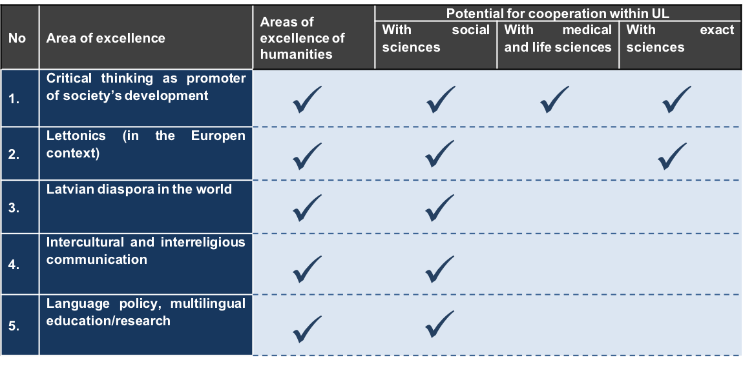
Figure 7. Areas of excellence in humanities and their research potential in cooperation with other fields.

Objectives, their main indicators and values
The objectives for the next five years in the field of humanities are divided according to the four development directions set by the University of Latvia:

1. scientific capacity and competitiveness;
2. alignment of research to economic needs and knowledge transfer;
3. human resources development;
4. promotion of international scientific cooperation.

The humanities sector objectives, as well as their operational performance indicators are included in the above Table 1. These indicators are measured and the results are managed in accordance with the UL result management policies.

Implementation plan and tasks
In order to reach the objectives, an institutional development and human resources development plan has been worked out. Deadlines and responsibilities for each task have been identified (Table 8).

Table 8. RP implementation plan

Nr | Activity | Year
 |  | 2016 | 2017 | 2018 | 2019 | 2020
General objectives for the implementation of the research programme
1 | To develop and approve a detailed change management plan.
2 | To nominate change management team.
3 | To implement a change management plan with the aim of regularly monitoring the progress of implementation of the RP and coordinate its implementation. .
1. Development direction - development of research capacity and research activity competitiveness in the European research space
Objective 1.1. To increase the research competitiveness of science groups in the European research space
4 | To define the evaluation approach to participation in international conferences and to set priority criteria for high level publications in scientific journals.
5 | To implement intersectoral cooperation planning measures at least once every 3 months by exchanging information about projects or publications in which cooperation is possible, identifying the needs of each subsector and competencies that can benefit other sectors.
6 | To work out the approach for regular research quality evaluations (in addition to quantitative indicators), evaluating the project quality at all stages of the research cycle.
Objective 1.2. To increase the research capacity of the sector group
7 | To set up a council for evaluation/improvement of project applications, to ensure the quality of international Project applications (maintaining the UL reputation).
8 | To design a a research projects identification, project preparation, implementation and completion system, providing administrative support to the scientific staff.
9 | To implement practical training and information/experience exchange at least once every six months for the preparation of research projects applications..
10 | To create an international scientific conference attendance support fund, providing funds as a matter of priority for attending conferences, participation in which will contribute to the increase of scientific ratings.
2. Development direction - Research relevance for economic needs and knowledge transfer
Objective 2.1. To increase the knowledge transfer potential

11 | To develop an organizational/administrative support system for researchers performing contract work and for participation in tenders.
12 | To set up research laboratories/offices for research directions with the potential to provide services and ensure active communication on research trends, achievements and the services offered (consultancy and applied research).
13 | Private sector involvement in the development of new study programmes or in improving existing programmes, with the potential to transfer knowledge and to attain internationally significant research potential.
Objective 2.2. To increase revenue from the transfer of knowledge

14 | To develop knowledge transfer strategies, with the aim of systematically fostering cooperation with economic operators in the sectors identified (such as private education, nursery, transport and educational services companies, travel companies, consulting companies, social partners, IT business environment, publishing houses, security systems, etc.).
15 | To create a service directory to identify the services that are provided for a fee and the services that can be provided free of charge, taking into account other considerations (e.g., visibility, publishing, promotion of cooperation).
16 | To identify the scientific areas in each subsector and to find potential clients for knowledge transfer for a fee.
17 | To develop an incentive funding model at the UL level so that the existing individual scientific research developed for clients can be a part of the UL activities.
Objective 2.3. To improve public awareness of scientific achievements

18 | To develop the process and UL support mechanisms for attracting contract work and dissemination of research results.
19 | To develop guidelines and define detailed activities for UL experts voicing their views in the media in order to increase public awareness of the UL as a Research University and public understanding of research activities implemented at the UL and the results obtained.
3. Development direction – Human resources development
Objective.1. To promote the renewal of research personnel.
20 | To design and implement the remuneration and motivation model for UL academic staff and to improve the existing remuneration system.
21 | To develop a system for the performance evaluation and motivation of UL employees.
22 | Based on the employee job satisfaction surveys and the results of the doctoral student focus group, to create a joint working group of the Personnel department and representatives from other structural units to decide on the solutions aimed at improving the UL worplace.
23 | To create a joint working group of the Personnel department and representatives from other structural units to agree on the evaluation criteria of the existing academic staff to promote gradual renewal of personnel.
24 | To introduce a succession system for academic staff.
Objective 3.2. To promote the development of scientific staff competencies
25 | To define the minimum required training and competency level for each post.
26 | To develop academic staff training plan for improving the scientific capacity and better involvement in scientific capacity-building process.
27 | To link the professional development of employees and the training system with the performance evaluation system.
4. Development direction - Promotion of international scientific cooperation
Objective 4.1. To develop international scientific cooperation networks

28 | To develop scientific methodology/manual to facilitate scientific cooperation.
29 | To create a database of the existing and emerging international scientific institutions, working groups, and individual researchers, in order to identify potential collaboration areas and to better assess the progress (the database is to be linked to the promotion of scientific cooperation methodology/manual).
30 | To develop individual and institutional arrangements for collaboration and contact network building and expansion.
31 | To define a support model for foreign visits by research staff and formulate a policy with the goal of promoting joint publications in international peer reviewed scientific journals.
Objective 4.2. To increase the mobility of research staff

32 | To create a communications strategy to update and expand the contact networks involving both individual employees and institutions (internal and external communication).
33 | To popularize academic positions and promote study opportunities internationally through collaboration and contact networks .
34 | To hold international competitions for academic staff positions.
35 | To provide funding for individual and institutional cooperation and networking contacts in order to attract more foreign guest speakers, students and scientific personnel.

Introduction

The Research Programme of the University of Latvia is a part of the development strategy of the University of Latvia for 2015-2020, developed in compliance with the Cabinet of Ministers regulation No 729 confirmed on November 25 2014: ”Regulations for the operational programme ”Etrepreneurship and innovation”, subsection 2.1.1.3.3: ”Development of the institutional capacity of scientific institutions”. The research programme aims to establish the Latvian University short, medium- and long-term research goals, identify and quantify the output indicators, their numerical values and tools of achieving research objectives and results. The research programme was developed taking into account: 1) the key initiatives set by the European Commission strategy 'Europe 2020'; 2) objectives, areas of specialization and growth priorities set by Smart Specialisation Strategies in Latvia; 3) guidelines for Latvia's science, technology development and innovation in 2014-2020.
The Research Programme comprises the following sections: four field research sub-programmes: exact sciences research sub-programme, medical and life sciences research sub-programme; social science research sub-programme and humanities research sub-programme. The research programme is structured into six parts:

1. research specifics and the existing situation description;
2. cooperation development plan;
3. scientific development feasibility studies;
4. research goals, performance indicators and numerical values;
5. tools for achieving research objectives and outcomes;
6. research programme alignment with the European Union and national planning documents.
The Research Programme is supplemented by Annexes, including: 1) the list of major research projects; 2) the list of top scientists and the key words describing their directions of research; 3) the list of significant publications and other results characterizing research capacity; 4) information on the number of students and graduates; 5) list of cooperation measures planned; 6) plan for participation in the European Union research and innovation support measures and technology initiatives; 7) targets and performance indicators for the period from 2015 to 2020, and others.

Central Statistics Office (2015), “Research Statistics” (informative review)
Central Statistics Board categorizes groups of research fields in Latvia into: life sciences, engineering sciences, medical sciences, agricultural sciences, social sciences and humanities. Data on exact sciences‘group are taken in the RP from the CBS data on natural sciences.
European Commission (2015) “Innovation Union Scoreboard 2015 – Report”. http://ec.europa.eu/growth/industry/innovation/facts-figures/scoreboards/files/ius-2015_en.pdf
The Ministry of Education and Science (2013). “Scientific, technological development and innovation guidelines for 2014-2020“ http://polsis.mk.gov.lv/view.do?id=4608
European Commission (2015) Innovation Union Scoreboard 2015 – Report”. http://ec.europa.eu/growth/industry/innovation/facts-figures/scoreboards/files/ius-2015_en.pdf
John Wood (2015). Speech at the conference “Research and Innovation for Global Challenges”. http://www.universityworldnews.com/article.php?story=20150515174058674
Central Office of Statistics (2015), “Research Statistics” (informative review). http://www.csb.gov.lv/sites/default/files/nr_36_petniecibas_statistika_15_00_lv.pdf
Central Statistics Board categorizes groups of research fields in Latvia into: life sciences, engineering sciences, medical sciences, agricultural sciences, social sciences and humanities.
European Commission (2014), “Horizon 2020 in brief: EU Research and Innovation Basic Programme”. https://ec.europa.eu/programmes/horizon2020/sites/horizon2020/files/H2020_LV_KI0213413LVN.pdf
Ministry of Education and Science (2013). “Scientific, technological development and innovation guidelines for 2014-2020“ http://polsis.mk.gov.lv/view.do?id=4608
European Commission (2015). “Innovation Union Scoreboard 2015 – Report”. http://ec.europa.eu/growth/industry/innovation/facts-figures/scoreboards/files/ius-2015_en.pdf
John Wood (2015). Speech at the conference “Research and Innovation for Global Challenges”. http://www.universityworldnews.com/article.php?story=20150515174058674
Central Office of Statistics (2015), “Research Statistics” (informative review). http://www.csb.gov.lv/sites/default/files/nr_36_petniecibas_statistika_15_00_lv.pdf
European Commission (2014), “Horizon 2020 in brief: EU Research and Innovation Basic Programme”. https://ec.europa.eu/programmes/horizon2020/sites/horizon2020/files/H2020_LV_KI0213413LVN.pdf
Ministry of Education and Science (2013). “Scientific, technological development and innovation guidelines for 2014-2020“. http://polsis.mk.gov.lv/view.do?id=4608
European Commission (2015). “Innovation Union Scoreboard 2015 – Report”. http://ec.europa.eu/growth/industry/innovation/facts-figures/scoreboards/files/ius-2015_en.pdf
John Wood (2015). Speech at the conference “Research and Innovation for Global Challenges”. http://www.universityworldnews.com/article.php?story=20150515174058674
Central Statistics Board (2015), “Research statistics” (informative review). http://www.csb.gov.lv/sites/default/files/nr_36_petniecibas_statistika_15_00_lv.pdf
Central Statistics Board categorizes groups of research fields in Latvia into: life sciences, engineering sciences, medical sciences, agricultural sciences, social sciences and humanities.
European Commission (2014), “Horizon 2020 in rief: EU Research and innovation basic programme”. https://ec.europa.eu/programmes/horizon2020/sites/horizon2020/files/H2020_LV_KI0213413LVN.pdf
Ministry of Education and Science (2013). “Scientific, technological development and innovation guidelines for 2014-2020“ http://polsis.mk.gov.lv/view.do?id=4608
European Commission (2015). “Innovation Union Scoreboard 2015 – Report”. http://ec.europa.eu/growth/industry/innovation/facts-figures/scoreboards/files/ius-2015_en.pdf
John Wood (2015). Speech at the conference “Research and Innovation for Global Challenges”. http://www.universityworldnews.com/article.php?story=20150515174058674

