Laser speckle imaging-assisted disk diffusion test for early estimation of sterile zone radius

Ilya Balmages*ª, Dmitrijs Bliznuks^{b}, Aigars Reinis^{c,d}, Svjatoslavs Kistkins^{c}, Emilija Vija Plorinaª, Alexey Lihachevª, Ilze Lihacovaª
ªUniversity of Latvia, Institute of Atomic Physics and Spectroscopy, Jelgavas 3, Riga, Latvia; ^{b}Riga Technical University, Zunda krastmala 10, Riga, Latvia; ^{c}Pauls Stradins Clinical University Hospital, Pilsoņu 13, Riga, Latvia; ^{d}Riga Stradiņš University, Dzirciema 16, Riga, Latvia.
*ilya.balmages@rtu.lv

ABSTRACT
The laser speckle imaging technique with sub-pixel correlation analysis allows to identify changes in the sterile zone radius, and makes it possible to predict these changes significantly earlier than the disk diffusion method which is recommended by the European Committee on Antimicrobial susceptibility testing (EUCAST). Results are oriented towards speeding and facilitating epidemiological analysis.
Keywords: microorganism activity estimation, laser speckle imaging, sensitive sub-pixel correlation method, image processing, microbial colony forming units

- INTRODUCTION
In previous studies using a non-contact optical technique called - laser speckle contrast imaging, we managed to determine the bacteria growth after 2-3 hours from the beginning of activity¹. Laser speckle is an interference pattern produced by coherent light reflected from the illuminated rough surface. If there are changes on the surface the individual speckle looks like it is “boiling”. This method allows tracking moving particles in optically inhomogeneous media. In our study of the laser speckle imaging method, a laser beam is scattered on a Petri dish where the test bacteria and antibiotic discs are located. A sub-pixel correlation analysis allows detection of small changes in bacterial activity.

- MATERIALS AND METHODS
  - The experimental setup
The laser speckles were generated by a 658 nm diode pumped solid state laser (output power 60 mW). Images were captured with 10-second intervals by a CMOS camera.
  - Microbial strains and cultivation conditions
Isolates of Escherichia coli, Acinetobacter baumanii, Staphylococcus aureus were chosen for the experiment. So far, experiments have been conducted on different bacterial cultures using antibiotics to which they are sensitive. To ensure accuracy, the experiments were conducted in a separate room in an incubator set to 37°C. The suspensions of the bacterial culture were prepared reaching 0.5 McFarland turbidity standard. Inoculation of bacteria on the agar was prepared according to EUCAST standard procedure². Then discs containing antibiotics were placed. The antibacterial sensitivity of the bacterial strains used in the study was as follows: E. coli was sensitive to Ampicillin 10 μg, Meropenem 10 μg, Ciprofloxacin 5 μg, and Amikacin 30 μg; A. baumanii was sensitive to Gentamicin 10 μg, Imipenem 10 μg, and Amikacin 30 μg; S. aureus was sensitive to Gentamicin 10 μg and Cefoxitin 30 μg.
  - Laser speckle image conversion to time signals
The field of experiment was divided into NxN pixels sections and the algorithm was executed on each of the sections.
1) A two-dimensional normalized correlation was performed between consecutive NxN image fragments throughout the experiment³. 2) The value that characterizes the changes that occur between consecutive frames was found by the offset at the location of the correlation peak. And to find a more accurate offset, interpolation is performed around peak⁴. 3) Offsets obtained between each pair of adjacent frames were accumulated, converting into time signal. To avoid the local transient spikes, a signal envelope within a certain window was used⁵.
An increase of signal values will occur when there is an activity increase (due to bacterial growth), and a decrease in signal occurs either due to nutrient depletion or due to the antibiotics action.

- RESULTS
  - Spatiotemporal analysis of sterile zone
After a few hours from the start of the experiment a disc of the sterile zone begins to form around the antibiotic. that is significantly earlier than by the disk diffusion method for the same bacterial species². In order to avoid the influence of noise, the signal envelopes over each radius were averaged. The averaged signal envelope is given in (Eq. 1).
(1)
Where 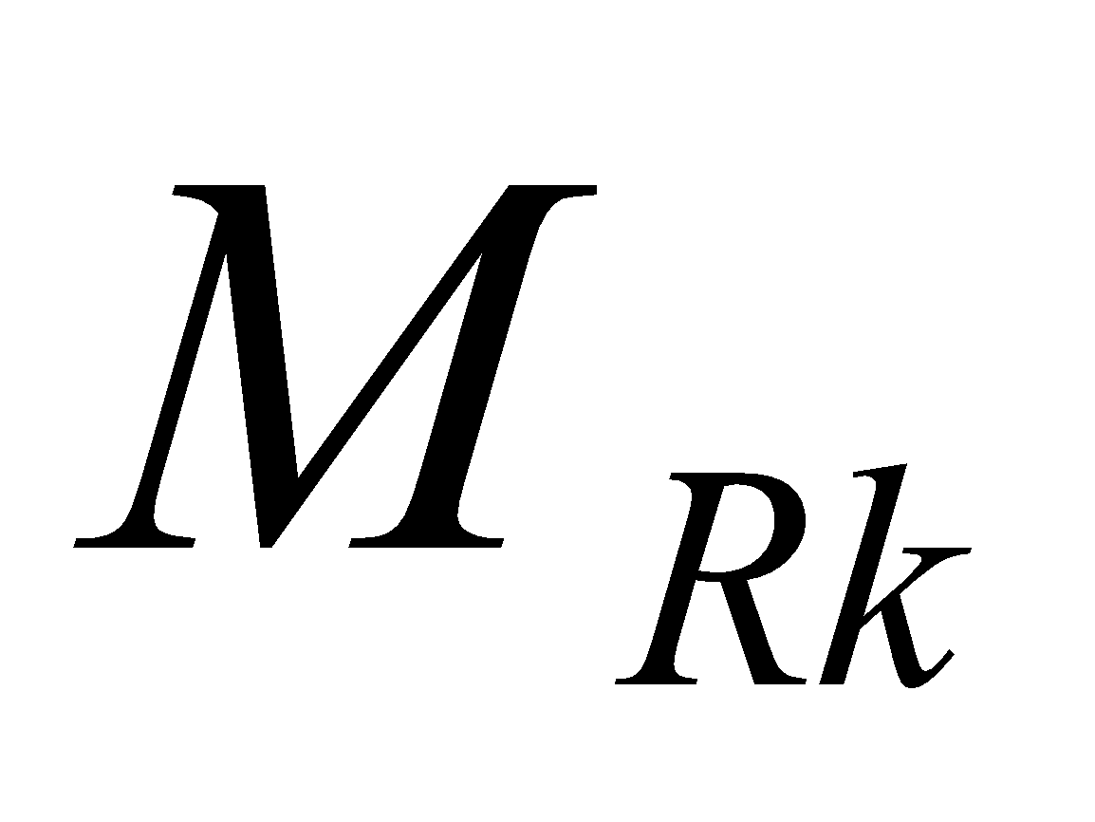 is the number of envelope signals at a given radius from the center.
The times when, after reaching the maximum, each average signal envelope decreases means that a sterile zone appears in this place at this time. Putting the averaged signal envelopes for all radii together, a spatio-temporal behavior of the sterile zone is obtained (Fig. 1).
Having also analyzed the signal in the time and frequency domain, it can be noted that as it moves away from the antibiotic, the energy level decreasing (which means the appearance of a sterile zone in this place) occurs later, and also the signal becomes more low frequency, (spectrograms in Fig.1). This behavior is correlated with the averaged signal envelopes for the corresponding radii (Fig1 "Change in sterile zone").
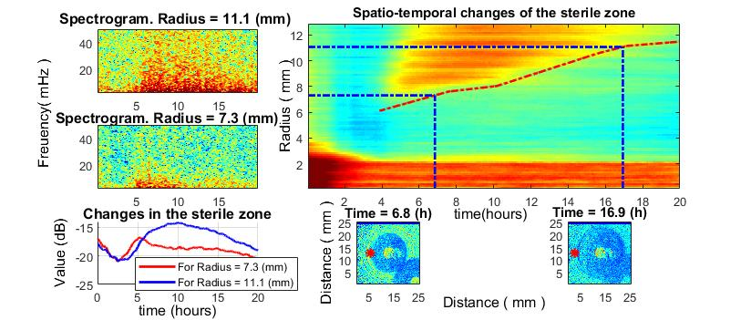
Figure 1. The growth of S. aureus around the imipenem disc. 1.) Spatio-temporal changes of the sterile zone (top-right). Spatiotemporal sterile zone growth curve (red). The blue lines in the direction to down indicate the times at which the disk images were taken. The blue lines in the direction to the left indicate the radii at which the spectrograms were taken. 2.) Sterile zone formation (2 time points) (bottom-right and bottom-center). The red stars indicate where the spectrograms were taken from. 3.) Spectrogram for signal in near and in far radius from antibiotic (2 radius points). 4.) Change of signal envelope over time for 2 different radii around the antibiotic (bottom-left).
  - The radius of the sterile zone for different bacteria species
In order to study the change in the radius of the sterile zone, several different bacteria species were used, which reacted to different antibiotics types (section 2.2). Spatiotemporal curves were obtained using the method described in 3.1 (Fig. 2).
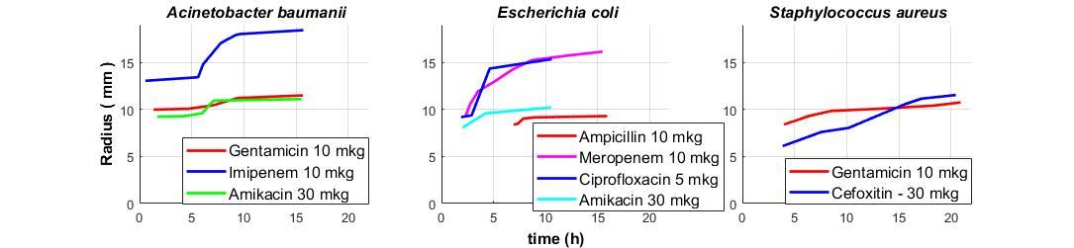
Figure 2. Spatio-temporal curves for different bacteria species as a response to different types of antibiotics.
From figure 2, it can be seen that different types of antibiotics cause different reactions in the same bacteria species. That is, the radius of the sterile zone and/or the growth rate of the sterile zone for the same bacteria species are different for different antibiotics as expected.
Based on the results obtained, it was decided to carry out a large number of controlled experiments in order to carry out a statistical analysis of the dependence of the size and growing rate of the sterile zone on antibiotics for the same bacteria species. This will make it possible to make a prediction for changing the radius of the sterile zone quickly, already at the initial stages of the experiment.
- CONCLUSIONS
In the current study, the ability of sub-pixel correlation analysis of laser speckle images to find radius growth curves of sterile zones for different bacteria species and different types of antibiotics was demonstrated. The results are aimed at developing an algorithm to make predictions of the radius of the sterile zone around the antibiotic disk much faster than using the standard disk diffusion method.

Acknowledgments
This work has been supported by the European Regional Development Fund project “Rapid assessment system of antibacterial resistance for patients with secondary bacterial infections” (No. 1.1.1.1/21/A/034).
REFERENCES
- Balmages I., Liepins J., Zolins S., Bliznuks D., Lihacova I., and Lihachev A., Laser speckle imaging for early detection of microbial colony forming units, Biomed. Opt. Express 12(3), 1609–1620 (2021).
- The European Committee on Antimicrobial Susceptibility Testing - EUCAST 2022, Clinical breakpoints - breakpoints and guidance, available online: https://www.eucast.org/clinical_breakpoints/
- Gåsvik K.J., Optical Metrology, 3rd ed. (John Wiley & Sons, New York, (2002).
- Lai, X., Torp, H., “Interpolation methods for time-delay estimation using cross- correlation method for blood velocity measurement. Ultrasonics, ferroelectrics, and frequency control,” IEEE Transactions 46(2), 277–290 (1999).
- Tukey J.W., Nonlinear (nonsuperimposable) methods for smoothing data, Proc. Con. Rec. EASCON, 673 (1974).

