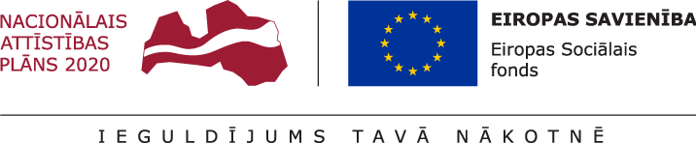

Open competition for foreign academic staff selection within the framework of Project Applications Selection Round of Specific Objective 8.2.2 "To Strengthen Academic Staff of Higher Education Institutions in the Areas of Strategic Specialization"
“Promoting the Employment of Foreign Academic Staff at the University of Latvia”

The aim of the Project – to promote the employment of foreign academic staff in the study direction Language and Culture Studies, Native Language Studies and Language Programmes thus contributing to the internationalization, export and international competitiveness of the University of Latvia.
Project results – 30% of the foreign academic staff who have received ESF funding continue to work as academic staff at the University of Latvia.
Project time period - from 4th quarter of 2021 to 3rd quarter of 2022, with minimum project participation set at 6 months.

Requirements and selection criteria for the beneficiaries:
- Persons who have been employed in the academic position of any accredited foreign higher education institution during the previous five years;
- Persons who hold a PhD degree in linguistic, literary, and intercultural studies in European and extra-European perspectives (American and Canadian) as well as who have research experience in America or Canada.
- Persons who have relevant academic work experience in delivering courses devoted to linguistics, American, (English) literature, culture and (also) media in Europe and America.
- Persons who have experience in organizing conferences devoted to European and American literature and culture.
- Persons who are experienced in conducting e-studies (e.g. on Moodle platform) and experienced in working in Web-based environment as well as who possess the digital skills required in humanities.
- Persons who have participated in international conferences (and seminars) devoted to American literary and culture studies.
- Persons who have published research articles on American literature and culture issues.
- Persons who hold membership for associations and societies with a focus on American (English) literature and culture and who have participated in activities of these associations.
- Persons whose English language competence, proficiency and skills correspond to C2 level which complies with the requirements set for academic, methodological and research work.
- Areas of work: literary studies with a focus on American literature, culture and media studies; academic work for the study programmes: a) BSP “English, European Languages and Business Studies”, b) MSP “English studies” at the Department of English Studies, the Faculty of Humanities, University of Latvia.
When applying for ESF funding, the following documents are required:
- Application – Annex 1
- CV - Europass or in a free form with respect to the above requirements and conditions

Annex 1:

APPLICATION
for ESF funding
within the framework of Project Applications Selection Round of ESF project “To Strengthen Academic Staff of Higher Education Institutions in the Areas of Strategic Specialization”

Study direction “Language and Culture Studies, Native Language Studies and Language Programmes”

I hereby certify that when applying for ESF funding for the project “To Strengthen Academic Staff of Higher Education Institutions in the Areas of Strategic Specialization” within the framework of the project application selection round in the field of study “Language and Culture Studies, Native Language Studies and Language Programmes”, I will perform the duties of the academic staff in conformity with the academic work, duties, workload and remuneration agreed and defined by the Study direction Council.

ESF funding applicant ____ ____ ____ ____ ____/____ ____ ____ ____ __/
signature printed name

____._____. 20 ____

The data specified in the application will be used by the UL exclusively for the purposes of ESF funding administration.

