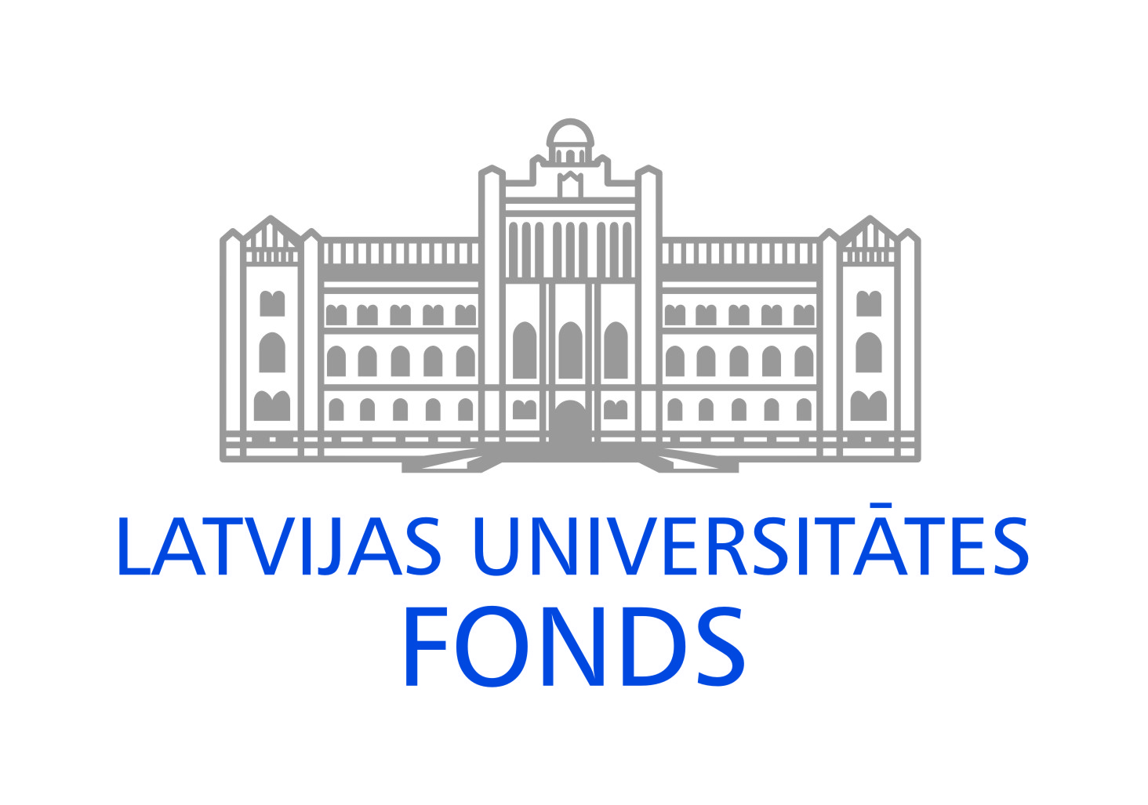
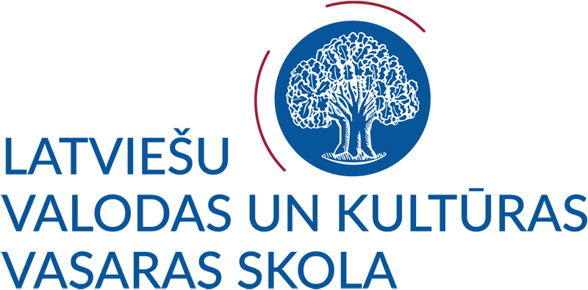
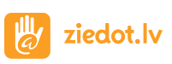

APPLICATION FORM
LATVIAN LANGUAGE AND CULTURE SUMMER SCHOOL 2022
for Ukrainian students, lecturers, researchers
12–25 July 2022 or 27 July – 9 August 2022

The application form must be completed using a computer.
Please, submit the completed application form electronically by 10 July 2022.
The applications received after the deadline will only be considered if there are remaining vacancies.
Carefully fill in the application form and send it to e-mail: sagkursi@lu.lv.

1. I would like to attend summer school on:
□ 12–25 July from 9:00 o’clock
□ 27 July – 9 August from 15:30 o’clock
2. Would you like to have the Latvian language lessons in summer school:
□ online (remotely)
□ on-site (attend in person)
□ both remotely and attend in person
3. Personal data 4. Contact details
First name: …………………………………………...  Last name: ………………………….……………..  Sex: □ Female □ Male  Date of birth (dd./mm./yyyy.):  ……………/…………..…/……………………  Personal ID number: …………………………………  (temporary)  Citizenship:………………………………………. | Street, house, apartment: …………………………….………….……  City/town: ………………  Postal index: …………  State:……………….…………….…..……  E-mail: …….………………….…….……...  Telephone: + .……………………..……...……
4. Occupation
Education (Name of educational institution/completed):
□ University …………………………… □ College/school……………….…… □ Other …………..………
□ Profession: ………………………………….… Current occupation:….………………
5. Participant’s institution of affiliation
Name of institution:.................................................... Faculty/department: ...............................................
Contact person of institution:...................................... E-mail: ……………......................................

6. Latvian language proficiency level of applicant:
A: basic B: intermediate C: highest
□ no preliminary knowledge
□ A1 – beginner □ B1 – intermediate □ C1 – advanced
□ A2 – elementary □ B2 – upper intermediate □ C2 – mastery
7. If you have studied Latvian, please provide information about your Latvian language learning experience
Educational institution:...............................Length of studies:.......................Study level:......................................
Textbooks, materials or online resources used:..........................................................................................
……………………………………………………………………………………………………………………
Please describe your Latvian language skills (e.g., conversational level, fluent):
.............................................................................................................................................................................
8. Language proficiency (please, underline accordingly)
Mother tongue:......................................
Other languages: English (basic, intermediate, excellent) German (basic, intermediate, excellent)
French (basic, intermediate, excellent) other........................ (basic, intermediate, excellent)
9. What are your interests?

I certify that the information provided in the application and in the annexes is true and correct.
If you want to cancel your participation in the summer school, please inform the organizers of the summer school about it by 10.07.2022. in writing by sending a message to the e-mail sagkursi@lu.lv.

The University of Latvia will process the personal data of the participants only for the academic and administrative requirements of the study process and research, scientific and statistical research, as well as in other cases arising from the students' contractual obligations or in the cases specified in the laws and regulations of the Republic of Latvia. If you have any questions about personal data protection, please contact the personal data protection specialists of the University of Latvia by writing to datu.specialisti@lu.lv.

The participant is released from liability for partial or complete non-compliance with the terms of participation of the “Latvian Language and Culture Summer School 2022”, if it has arisen due to force majeure, incl. the spread of the COVID-19 virus in the European Union and worldwide (pursuant to new laws and regulations issued by the state and the European Union).

Date ……./……/2022 Signature……………………………...

