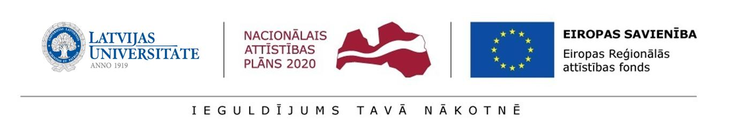Annex 6
Regulation of the University of Latvia of postdoctoral applications

CONFIRMATION
regarding the support of a scientific/scientific sector consultant
for submission to the State Education Development Agency (SEDA) for the research application selection round for Activity 1.1.1.2 “Post-doctoral Research Aid” of the Specific Aid Objective 1.1.1 “To increase the research and innovative capacity of scientific institutions of Latvia and the ability to attract external financing, investing in human resources and infrastructure” of the Operational Programme “Growth and Employment”

Consultant:
Given name, surname
Institution, field, position
Qualification of the consultant and the level of experience related to the research direction of the research application:
international co-operation

participation in projects

publications

patents
any other achievements related to the research application within the past 5 years

Hereby I certify that I have been informed and I agree to collaborate with the postdoctoral researcher

_____________________________________________________________________
^{given name, surname}
Consultant _______________ /__________________/____._____. 20____
signature transcript of signature date

Scientific/scientific sector consultant – a person of the submitter of research application or partner institution – leader of department, group, study direction, department, or other structural unit where postdoctoral researcher will be included and who will be able to provide support to postdoctoral researcher.

