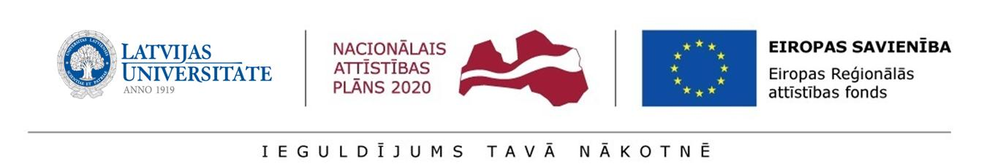
Annex 1.4
Regulation of the University of Latvia on the second round preliminary selection of postdoctoral applications

CONFIRMATION for the University of Latvia
regarding co-operation within the scope of implementing the research application
_____________________________________ (name)

Submission of Research Applications for Selection Rounds of Research Applications to SEDA under the Activity 1.1.1.2 “Post-doctoral Research Aid” of the Specific Aid Objective 1.1.1 “To increase the research and innovative capacity of scientific institutions of Latvia and the ability to attract external financing, investing in human resources and infrastructure” of the Operational Programme “Growth and Employment”

Hereby it is certified that _____________________________ (legal name of the institution),
represented by ____________________________________________ (position, given name, surname) undertakes to co-operate with the postdoctoral researcher ______________________ (given name, surname) within the scope of the aforementioned research application as a co-operation partner.

Hereby I confirm my readiness to accept the postdoctoral researcher at my institution, to ensure access necessary for performance of research, infrastructure and other resources in order to implement the activities planned in the research application (without gaining advantages or intellectual property rights arising from the activities carried out within the scope of the research application).

Authorised signatories of the institution²

__________________/________________________/________________/__________ position signature transcript of signature date

If the letter is drawn up by a foreign partner, the University of Latvia shall submit the translation thereof in Latvian (notarised translation is not required) ² Authorised signatories of the partner organisation (head of an institution, faculty dean of an institution, department director of an institution, director of a scientific institute of an institution). ³ The certification shall be supplemented with information which provides assurance that the relevant letter has been signed by an authorised signatory (by indicating the link to the website of the co-operation partner’s institution, where information on the authorised signatories of the co-operation partner is accessible, or by appending the authorisation of the c-operation partner’s institution (a power of attorney, internal normative act, certification on administrative management), attesting that the person having signed the letter of the co-operation partner is to be regarded as an authorised signatory).

