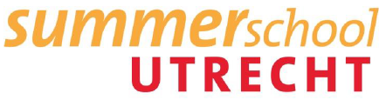
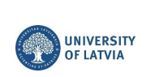
Course: | Standing for the West on Its Borderlands: Soft and Hard Security Dilemmas and Opportunities of the Baltic States
Version: | February 2023
First Day Riga: | Monday 17th of July, 2023  University of Latvia  Raina blvd. 19, Riga, Latvia, LV-1586

WELCOME TO LATVIA
Latvia is a country in Northern Europe, one of the three Baltic countries. In 2004 Latvia joined NATO and European Union. The best thing about Latvia is that it is so green and filled with forests, lakes and meadows. Latvia is a much enjoyed location among hikers, campers and nature lovers.
Riga is the capital of Latvia. It is the largest city of the Baltic States and home to one third of Latvia’s population. The climate of Riga is humid continental. The coldest month are January and February. The summers in Riga are warm and humid with an average temperature of 18⁰C, while the temperature on hottest days can exceed 30⁰C.

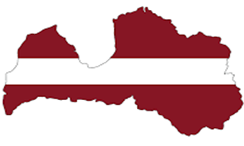

Key facts:
Name: Republic of Latvia;
Founded: November 18, 1918;
Area: 64, 589km²
Population: 1,92 million;
Speaking language: Latvian;
Currency: EUR
International code: LV
Time: GMT+2
International telephone code: +371
Emergency number: 112

How to get to Latvia?
By plane:
Riga International Airport (RIX) [in Latvian: Starptautiska Rigas Lidosta]. Airport is located 10 km southwest from Riga centre.
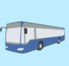
By bus:
There are international bus connections to anywhere in Europe.
-Econlines;
-Simple Express;
-Eurolines Lux Express;
-Flybus (from Riga, Kaunas and Vilnius);
-Flixbus.

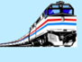
By train:
Latvian Railways connects many Latvian cities as well as few countries outside Latvia, such as Belarus and Estonia.

How to get from the airport to the city centre?
●By Taxi: Bolt (App), Panda Taxi, Red Cab, and AirBaltic 15 min drive; 10-30 EUR (depends on location and time of the day) | ●By Public Transport: Take bus No. 22 and go until stop Autoosta (you will arrive in the very city centre, next to the Central Station/shopping centre Stockmann) 30-40min drive

Additional information about public transport!
One ride ticket for buses, trams and trolleybuses costs EUR 1.50. You can get the ticket at “Narvesen” kiosks. It is possible to purchase E-tickets (E-talons) also for two or more rides.

When entering public transport – bus, trolleybus or tram, a passenger has to validate the ticket on every ride of public transport you take. Electronic validators are located in public transport vehicle’s. If you decide to take the risk and drive without ticket, you should know that the penalty is from 20 EUR.
Dear participant,
this summer school will provide an overview of one of the key trends in soft and hard security dilemmas and opportunities of the Baltics states. The objective will be to expose students to the latest trends in soft and hard security dilemmas (with more practical examples), including, countering disinformation, critical thinking, media literacy, propaganda and emotions and their impacts on large scale groups.
The University of Latvia offers a multidisciplinary course that focuses on topical issues in a present day society. The course will provide insight on how the ‘big neighbors’ influence the development of small countries such as the Baltic States. During the course, an overview of one of the key trends in soft and hard security dilemmas and opportunities of the Baltics states will be provided. Including, countering disinformation, critical thinking, media literacy, propaganda and emotions and their impacts on large scale groups.

We advise you to read this document carefully and bring it with you on your journey as a travel guide. If you have any further questions, please feel free to contact us.
Location of the event: Raina Blvd. 19, Riga
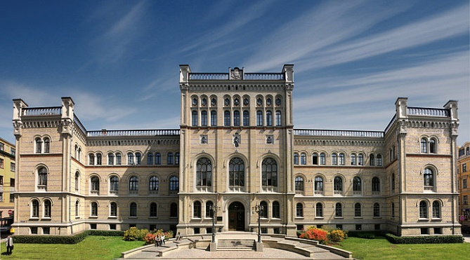
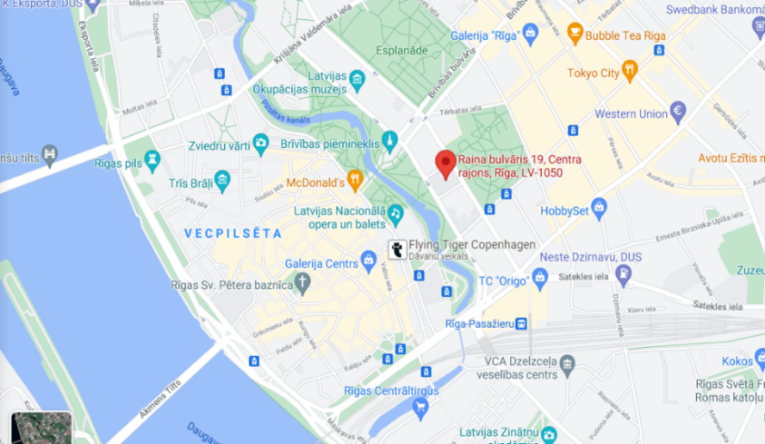

Contact persons:
Marta Vilkauša
International Coordinator, UL Mobility Division
marta.vilkausa@lu.lv

Aleksandra Kjakste
International Coordinator, UL Mobility Division
aleksandra.kjakste@lu.lv

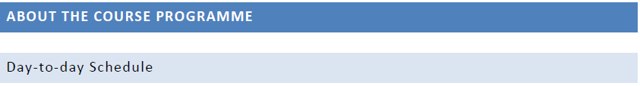

You can download the course schedule on the course page.

- Valid passport (an ID card is not valid unless you are an EU citizen);
- Travel insurance which covers medical costs, liability, accidents and expatriation to your home country in case of emergencies;
- Some cash money (EUR) for any case for your first meals, drinks, transportation etc.;
- A converter for European plugs (if necessary);
- ISIC Card or Student ID;
- Medication (if you need anything special);
- Warm sweater/windbreaker (it can get cold and rainy in summer too);
- Summer hat and sun cream;
- Swimsuit, slippers (seaside is close to the city);
- Toiletries (towel, hygiene items);

Latvia is a part of the Schengen area. EU/EEA citizens are not required to have a visa to enter Latvia. If you are a non-EU/EEA citizen, please, check if you require the Schengen Visa, as there are visa-free countries whose citizens do not need visa to enter Latvia. However, these citizens may reside in Schengen area only max. 90 days within a 6 months period. The citizens of other countries need to apply for visa prior to their arrival to Latvia. In case of doubts regarding the need of having a visa, please contact Marta Vilkausa.
More information about entry to Latvia can be found here.
All accepted Summer school participants will be contacted and informed about the visa procedure.
Before travelling to Latvia, please visit https://covid19.gov.lv/en for information regarding the epidemiological safety measures in Latvia.

All participants must have a life and health insurance:
1) For EU citizen – at least European Health Insurance Card (EHIC)
2) For non EU citizens – life and health insurance policy which is valid in Latvia and in all Schengen countries and which ensures at least the following health care services:
- emergency medical assistance costs;
- treatment costs of growing chronic illness;
- transport costs to the closest medical facility providing the Services mentioned above;
- transportation costs to return the patient to his/her home country in the case of a serious illness or death.
The minimum limit of insurer's risk of own account indicated in the policy should not be less than 42 600 EUR.
Find some of the clinics below:
- Medical Care Centre “ARS”/ Medicīnas sabiedrība „ARS” (Skolas str. 5, Phone No. 67201006, 67201007, 67201008).
- "Health Center 4" / „Veselības centrs 4” (Kr. Barona Street 117, Phone No.: 67847100)
Pharmacies in Latvia are called „Aptieka”

The majority of grocery stores are open from 8 a.m. - 9 p.m., shopping malls mainly work 10 a.m. - 9 p.m. The majority of shops are closed on Sundays, except the shopping malls and some small food stores. Recommendable is the Central market where you can buy fresh products (vegetables, fruit, berries, flowers, meat, fish etc.).
Participants should bear in mind that if they wish to travel around Latvia and lead an active social life, they should expect to spend about EUR 400-600 monthly.
If you want to buy something to remind you of your stay in Latvia, most likely it will be local handicrafts, works of art or books. Latvia is famous for its chocolate, manufactured by the oldest Latvian enterprise “Laima”, as well as for ceramics and amber.

Some prices:

Combo Meal at McDonalds or similar approx. 4.98 EUR
Cappucino (regular) approx. 2.50 EUR
Coke/Pepsi (0.33 liter bottle) approx. 0.86 EUR
Water (0.33 liter bottle) approx. 0.67 EUR
Apples 1 kg approx. 0.91 EUR
Potatoes 1 kg approx. 0.42 EUR
Bottle of Wine (mid-range) approx. 5.40 EUR
Domestic Beer (0.5 liter bottle) approx. 0.88 EUR
Imported Beer (0.33 liter bottle) approx. 1.21 EUR
Pack of cigarettes (Marlboro) approx. 4.00 EUR
Chocolate Laima from 0.90 EUR

Debit cards have become a most common means of payment in Latvia, they are accepted almost everywhere (except or e.g. market).
Cash machines (ATM) are available all around the city centre and at the majority of banks, shopping malls, major petrol stations, airport etc.

Electricity in Latvia is 220 Volts.

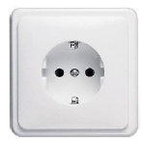

Mobile telephone service providers, prices and terms are available on each respective company’s website:
www.lmt.lv
www.tele2.lv
www.bite.lv

The University of Latvia will provide students with free WiFi access on UL campus.
In addition, most of cafes/restaurants in Latvia offer free WiFi connection.

The University of Latvia does not arrange housing, but can of course advise.
Some options: you can stay also in a hotel in the city centre.
Student Hotel: Duck Republik
Adress: Lauvas iela 1, Riga
https://duckrepublik.eu

Dodo Hotel
Adress: Jersikas iela 1, Riga
https://bit.ly/3xCSmSm

Wellton Centrum Hotel & SPA
Adress: Kaleju iela 33, Riga
https://www.wellton.com/lv/viesnicas/wellton-centrum-hotel-and-spa

Ibis Riga Centre
Adress: Marijas Iela 5, Riga
http://ibisrigacentre.lv/
Rixwell Hotel Gertrude
Adress: Gertrudes iela 70, Rīga
https://www.rixwell.com/en/hotels/rixwell-gertrude-hotel
Stabu Sēta Residence
Adress: Stabu iela 8, Riga
http://stabuseta.com/
Radisson Blu Latvija Conference & Spa Hotel
Adress: Elizabetes iela 55, Riga
https://www.radissonhotels.com/en-us/hotels/radisson-blu-conference-riga-latvija-spa/contact
Radisson Blu Riga Elizabete
Adress: Elizabetes iela 73, Riga
https://www.radissonhotels.com/en-us/hotels/radisson-blu-riga-elizabete

Radisson Blu Daugava
Adress: Kugu iela 24, Riga
http://bit.ly/3ICRC6g

To the attention of all participants!
Please take note that the hotels above are for suggestions only. The University of Latvia is not responsible for the services and quality of these hotels.

Lido (place for lunch if you want to enjoy typical Latvian food)
Adress: Lido Vermanitis, Elizabetes iela 65, Riga
https://www.lido.lv/lv/kontakti/lido-vermanitis
Wok to Walk (place for lunch)
Aspazijas Boulevard 30, Riga
Let Enzo Out (place for lunch)
Kr.Barona iela 11, Riga
Ogle (place for lunch & coctails)
Address: Kalku iela 4, Riga
La Kanna (place for lunch)
Address: Terbatas iela 5, Riga
https://www.lakanna.lv/lv/
Folkklubs ALA (place for an evening with latvian food, music, dances)
Peldu iela 19, Riga
Here are some places that you can visit while in Riga!
https://www.latvia.travel/en/article/top-10-must-see-riga

