Application form
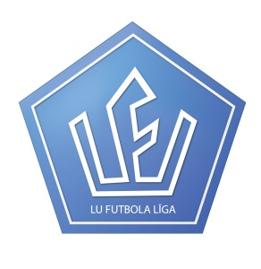

UNIVERSITY OF LATVIA
FOOTBALL LEAGUE

International students’ team ET 2015/2016

Please fill and send application form to the e-mail: maartins.linde@gmail.com
INFORMATION ABOUT PLAYER

Full Name
Home Country
Date of birth
Home University
Faculty at University of Latvia

Study period at University of Latvia
Facebook link
Phone number(s)
How often do you play football?
How many years do you play football?
What football team(s) have you played for and at what level of competition?
Which position do you play the best?
What is your favorite football team?

More information: Martins +371 29811900, maartins.linde@gmail.com
Facebook link: https://www.facebook.com/martins.linde.3

